Waterbird Count
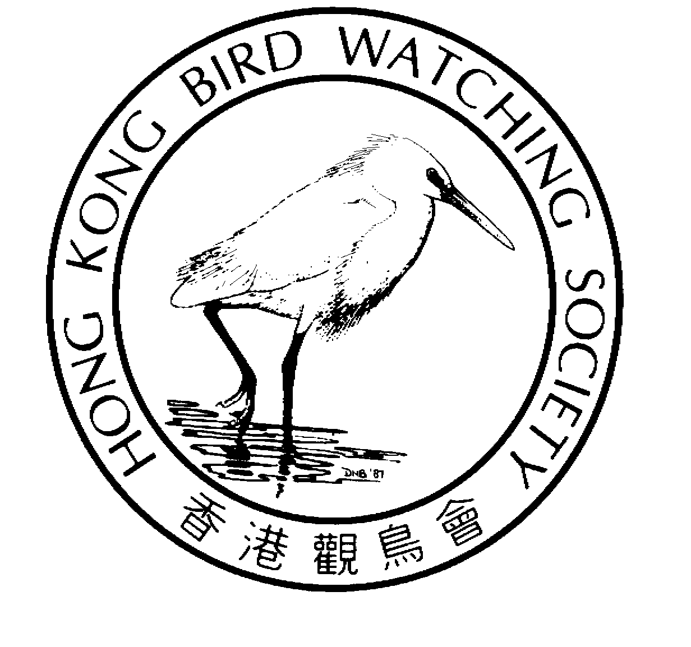 | Organized by  The Hong Kong Bird Watching Society  香港觀鳥會策劃
 | Sponsored by  Agriculture, Fisheries and Conservation Department  漁農自然護理署資助

Training Workshop
水鳥普查訓練工作坊
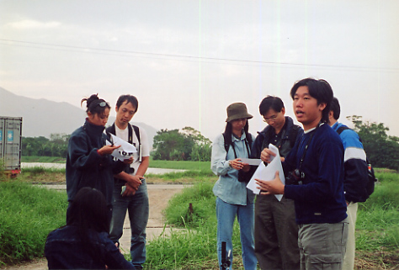

The Waterbird Monitoring Programme is an integrated professional programme coordinated and reported by HKBWS. The Waterbird counts began at 1979. Since 2000, this project was supported by Agriculture, Fisheries and Conservation Department.

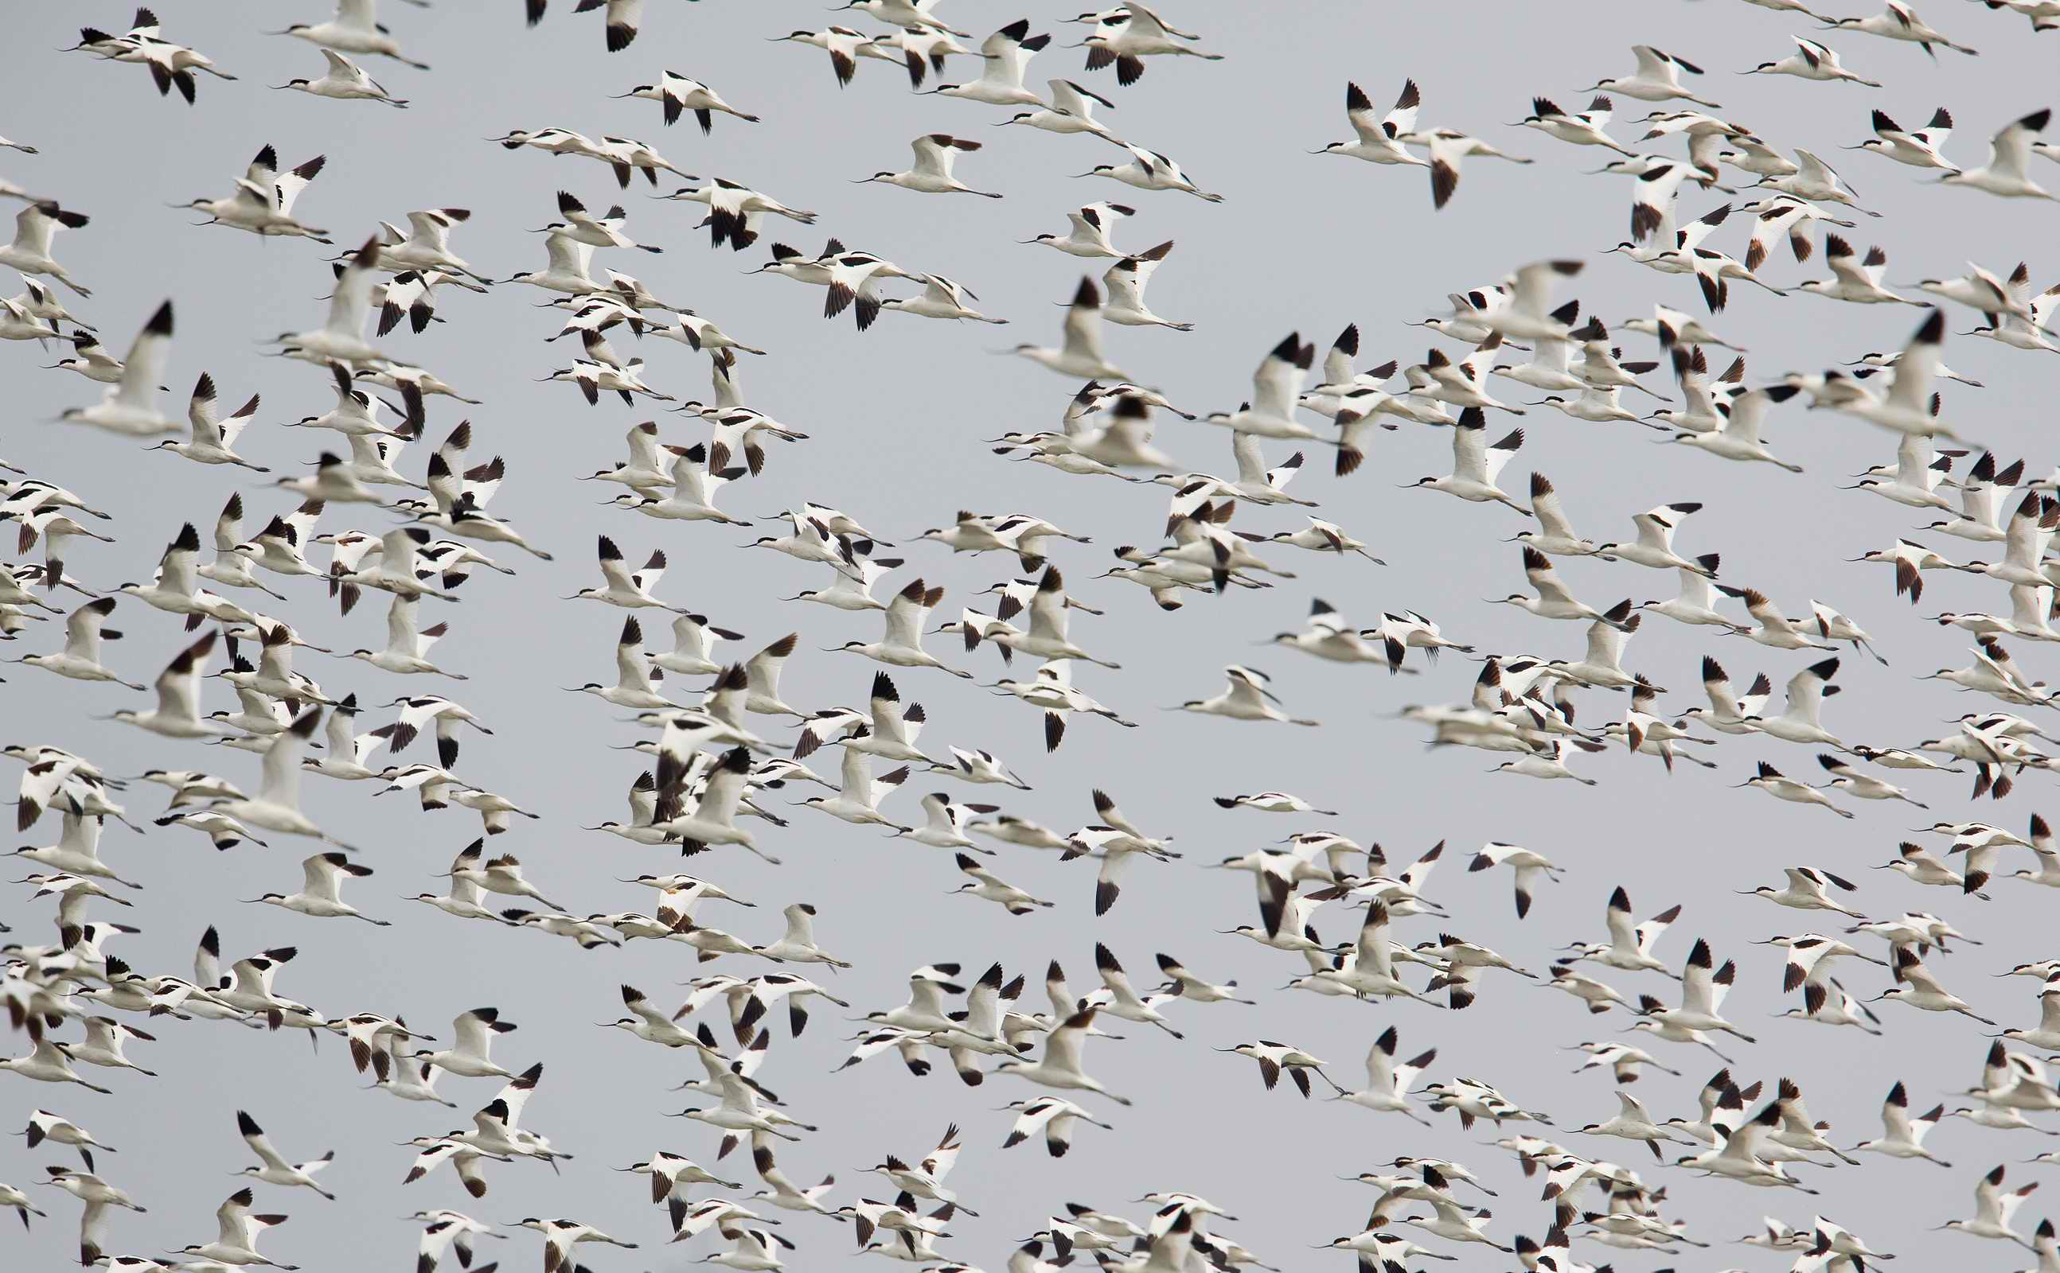
This is one of the largest programme of the Society with more than 30 active volunteers contributing their time, carrying out bird survey throughout the year, to collect population data at species level. The programme consists of three parts (1) Monthly Waterbird Surveys; (2) Shorebird Surveys and (3) Egretry Counts. These data are essential for monitoring the value of wetlands, endangered species, population and environmental changes. It forms an important component of the conservation and management of the Mai Po Inner Deep Bay Ramsar Site.

The “Waterbird Count Training Workshop” is an annual event designed to allow more individuals to participate in waterbird count, especially those with at least 1 year experience in bird watching. It is a good opportunity to learn the techniques required for waterbird counting at the Mai Po Inner Deep Bay area, plus, of course, the satisfaction of contributing to the conservation and management work of the Ramsar Site.

Allen

水鳥普查是香港觀鳥會策劃及定期匯報調查結果的專業項目。項目於一九七九年展開，二零零零年起，獲漁農自然護理署資助進行。
Programme highlights include:
- History of waterbird count in Hong Kong;
- Techniques of bird counting and habitat monitoring;
- Practicing at Mai Po

活動重點：
- 了解香港水鳥普查的歷史
- 野外實習水鳥和生境調查
- 在米埔點算

Bring your binoculars and permit if available.
必須自備雙筒望遠鏡，如有米埔證請務必帶同。

是項全年性的普查由幾十位資深鳥友於工餘時間進行，收集各鳥種數量資料。普查項目包括(1)每月水鳥普查；(2)遷徙水鳥統計以及(3)白鷺林統計。這些數據正是監察濕地變遷及其瀕危品種的重要基礎，成為管理及保育內后海灣國際重要濕地的重要部份。

「水鳥普查訓練工作坊」是本會一年一度舉辦的訓練項目，適合已經有最少一年觀察水鳥經驗的鳥友，目的是讓更多人認識鳥類普查的技巧，並鼓勵及提升更多鳥友參與水鳥普查工作。更重要的是，讓大家直接參與和貢獻在國際重要濕地的保育和管理工作，從而獲取更大的滿足感。

歡迎各位參與「水鳥普查訓練工作坊」。

Waterbird Count Training Workshop |  | 水鳥普查訓練工作坊
17 Mar 2012 (Saturday) |  | 2012年3月17日(星期六)
9:00am–12:30 |  | 上午9:00至中午12:30
Mai Po Car Park |  | 米埔停車場集合

Registration is free – but space is limited 費用全免，名額有限

REGISTRATION 登記表格

Please register by fax or e-mail 登記可以傳真或電郵方式 (Fax：2314 3687 E-mail: hkbws@hkbws.org.hk)
I’d like to attend the Waterbird Count Training Workshop on 17 Mar 2012
我想參加2012年3月17日的水鳥普查訓練工作坊

Name 姓名:__________________________ Contact no聯絡電話.: ______________ E-mail電郵: ______________________

Address地址:_____________________________________________________Membership No.(if any) ____________________

Hong Kong Bird Watching Society 香港觀鳥會
14/F., Ruby Commercial Centre, 480 Nathan Road, Kowloon 九龍彌敦道480號鴻寶商業大廈14樓

