鷺鳥林普查訓練工作坊2012
Organized by
The Hong Kong Bird Watching Society
香港觀鳥會策劃
Sponsored by
Agriculture, Fisheries and Conservation Department
漁農自然護理署資助

Egretry Count

Training Workshop 2012
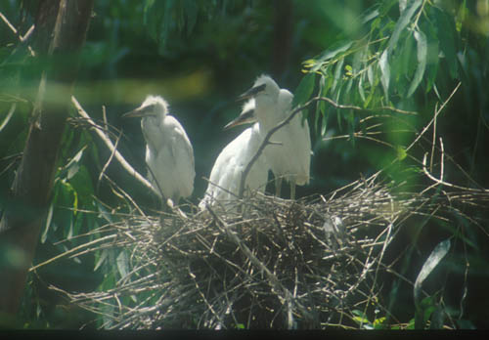

水鳥普查是香港觀鳥會策劃及執行的專業雀鳥普查計劃。項目於一九七九年展開，二零零零年起更獲漁農自然護理署資助進行。

鷺鳥林普查為水鳥普查計劃的一部份，由本會的鷺鳥研究組協助執行，收集於繁殖季節時的鷺鳥繁殖地、鳥種及鳥巢數量的資料。這些資料正是監察濕地的變遷、雀鳥的數量及生態環境狀況的重要根據。

本會舉辦「鷺鳥林普查訓練工作坊」的目的是希望讓更多市民認識鷺鳥林及鷺鳥普查的技巧，從而參與鷺鳥林普查工作。更重要的是，讓大家直接參與和貢獻生態保育的前線工作，從而獲取更大的滿足感。

歡迎會員參與「鷺鳥林普查訓練工作坊」！

The Waterbird Monitoring Programme is an integrated professional programme coordinated by The Hong Kong Bird Watching Society (HKBWS). The Waterbird counts began in 1979. Since 2000, this project has been funded by Agriculture, Fisheries and Conservation Department.

The Egretry Count is a part of the Waterbird Monitoring Programme, coordinated by the Egret Research Group of the HKBWS. The Egretry Count collects information on types of species, number of nest and condition of breeding sites of egrets and herons. These data are essential for monitoring the value of wetlands, population and environmental changes..
活動重點：
- 介紹鷺鳥林及鷺鳥普查的歷史
- 介紹普查鷺鳥林的技巧
- 考察兩個鷺鳥林、實習點算技巧

Programme highlights include:
- History of egretry count in Hong Kong;
- Techniques of counting nests in different types of nesting colonies and;
- Field trials at 2 colonies

* 請自備雙筒望遠鏡
* Bring your binoculars

The aim of the “Egretry Count Training Workshop” is to allow more members of the public to participate in the Egretry Count. It is a good opportunity to learn the techniques required for counting of nests of egrets and herons, and to gain the satisfaction of contributing to nature conservation directly..
Language 語言: Cantonese 以廣東話為主

Egretry Count Training Workshop |  | 鷺鳥林普查訓練工作坊
28 Apr 2012 (Saturday) |  | 2012年4月28日(星期六)
Time: 9:00 am – 1:00 pm |  | 時間：早上9:00至下午1:00
Meeting Place: Car Park, Mai Po Nature Reserve |  | 集合地點：米埔保護區停車場

Registration is free – but space is limited 費用全免，名額有限---------------------------------------------------------------------------------------------------------------------------------------------------

REGISTRATION 登記表格

Please register to us by fax or e-mail 登記可以傳真或電郵方式 (Fax：2314 3687 E-mail: hkbws@hkbws.org.hk)

I wish to attend the Egretry Count Training Workshop on 28 April 2012
我想參加2012年4月28日 的鷺鳥林普查訓練工作坊

Name 姓名:__________________________ Contact no聯絡電話.: _______________

E-mail電郵: _________________________________
14/F., Ruby Commercial Building, 480 Nathan Road, Yaumatei, Kowloon, Hong Kong
香港九龍油麻地彌敦道480號鴻寶商業大廈14樓
Tel 電話: 2377 4387 Fax.傳真: 2314 3687 E-mail電郵: hkbws@hkbws.org.hk

