「猜尋呈」香港觀鳥記錄比賽2012
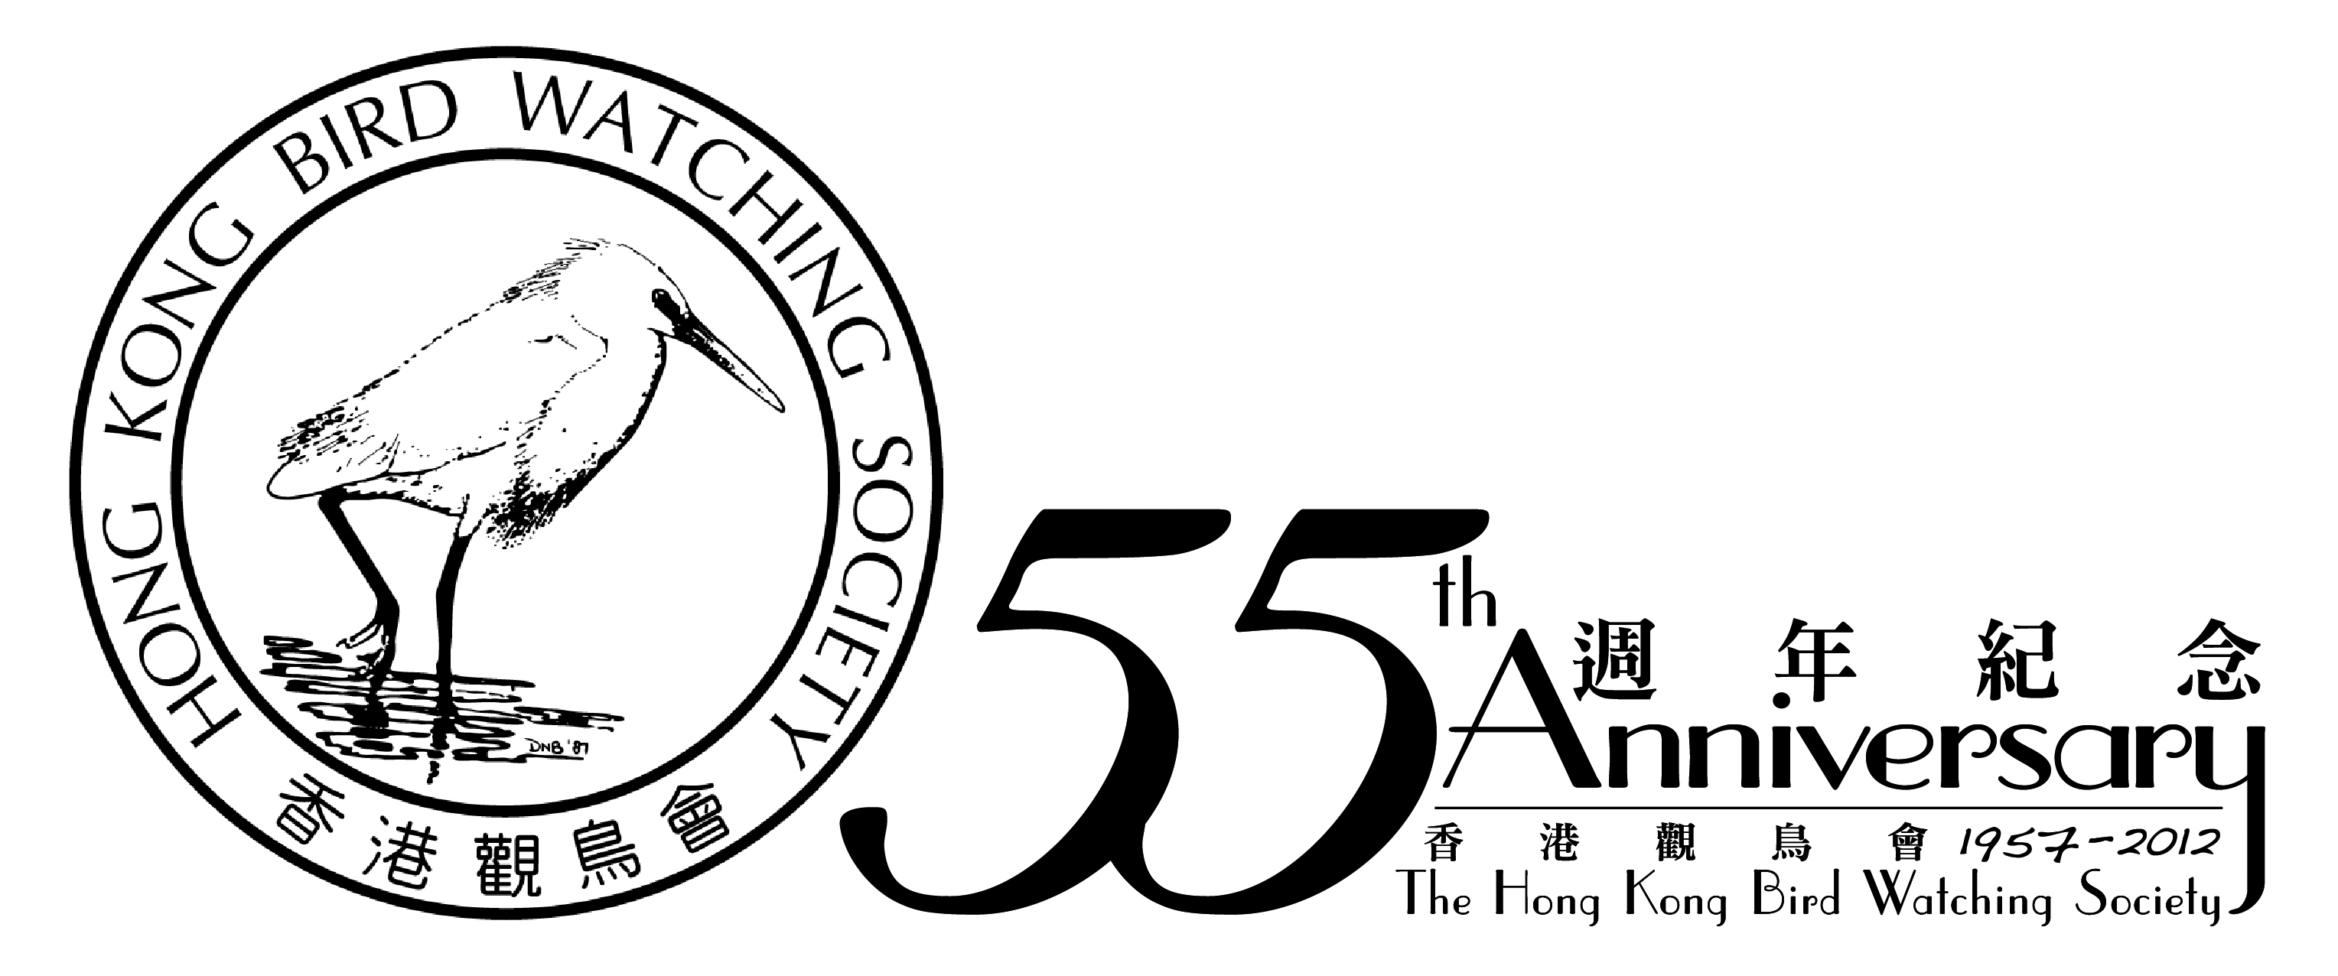
暨 籌款活動

報名及捐款表格

致：香港觀鳥會 (傳真號碼：2314 3687 電郵: hkbws@hkbws.org.hk 查詢: 2377 4387)

(1) 本人未克參與是次比賽，但願意捐款支持鳥類保育工作：
港幣$1,000 港幣$500 港幣$200 (其他)港幣$___________
捐款人姓名：__________________________________________________聯絡電話：___________________________
捐款人地址：__________________________________________________聯絡電郵：___________________________

(2) 我們報名參加比賽，報名費用(每隊) 港幣$600

隊伍名稱：(中文) (英文)
隊長姓名：1) (中文) (英文) |  | 隊長電郵：
隊長電話：(手提) |  | 隊長電郵：
隊員姓名： | 2) (中文) (英文) | 5) (中文) (英文)
隊員姓名： | 3) (中文) (英文) | 6) (中文) (英文)
隊員姓名： | 4) (中文) (英文)

(3) 我們會參與聚餐及頒獎禮，共_____________位 （費用及詳情另行通知）
(4) 我們報名參加訓練活動
訓練日期 | 訓練地點 | 報名人數
2012年3月18日 (上午8至下午3時) | 大埔滘 及 南生圍
----------------------------------------------------------------------------------------------------------------------------------

 籌 款 表 格 
贊助人姓名 | 如需收據  請✓ | 贊助金額 | 贊助人姓名 | 如需收據  請✓ | 贊助金額 | 贊助人姓名 | 如需收據  請✓ | 贊助金額

*捐款港幣$100或以上可獲本會發出收據，可作扣減稅款項目 (請在表格內註明)
*此表格可自行複製
*捐款可立即繳交，或最遲於比賽後兩星期內繳交
*繳款辦法：
－捐款可以支票繳付，抬頭「香港觀鳥會」 或 「The Hong Kong Bird Watching Society」；
－可將捐款存入本會中國銀行（香港）的戶口：012-878-1-076439-9，再把收據連此表格寄回本會；
－亦可以親臨本會以現金或支票繳付。

香港觀鳥會地址：香港九龍油麻地彌敦道480號鴻寶商業大廈14樓

Records 215 -
HK Bird Watching Competition 2012
Pledge Form & Registration Form

To: HKBWS Office (Fax: 2314 3687 E-mail: hkbws@hkbws.org.hk Tel: 2377 4387)
- I am / We are not able to participate in the competition, but would like to donate:
$1,000 $500 $200 $____________
Name of Donor:______________________________________ Contact No.: _________________________________
Address of Donor: _____________________________________Email: ____________________________________
(2) We would like to register in the competition. Registration Fee per team: HK$600
Name of the Team: (Eng) |  | (Chi)
Name of Team Captain:1) |  | E-mail：
Mobile Phone No.: |  | E-mail：
Team Member: | 2) | 5)
Team Member: | 3) | 6)
Team Member: | 4)

(3) We shall have___________ team member(s) attending the Lunch gathering. (Charges & details: to be advised)

(4) We would like to join the competition training
Date & Time of Training | Location | No. of Participants
18 March 2012 / 08:00-15:00 | 大埔滘 及 南生圍
------------------------------------------------------------------------------------------------------------------------------------------

 Pledge Form 
Name of Donor | Receipt  (✓) | Amount | Name of Donor | Receipt  (✓) | Amount | Name of Donor | Receipt  (✓) | Amount

*Donation of or above $100 is tax deductible (please put a ✓ in the box)
*This form could be duplicated if necessary.
*Donation could be paid at your convenience or within one week after the Race.
*Method of payment:
－By cheque payable to “The Hong Kong Bird Watching Society” and send to our office;
－Direct credit to Bank of China (HK) Account Number: 012-878-1-076439-9, then return the receipt with this form to us;
－You can also visit our office in person.

*Office Address: 14/F., Ruby Commercial Building, 480 Nathan Road, Kowloon

