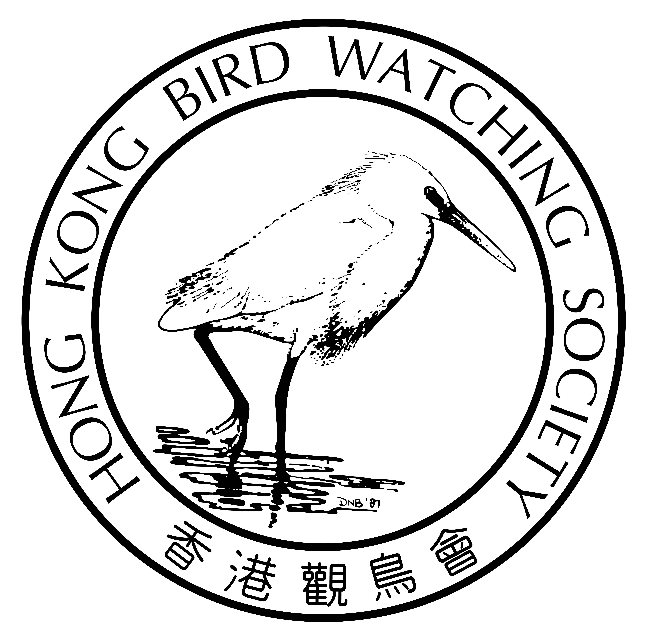
廣東海豐鳥類省級自然保護區 觀鳥活動

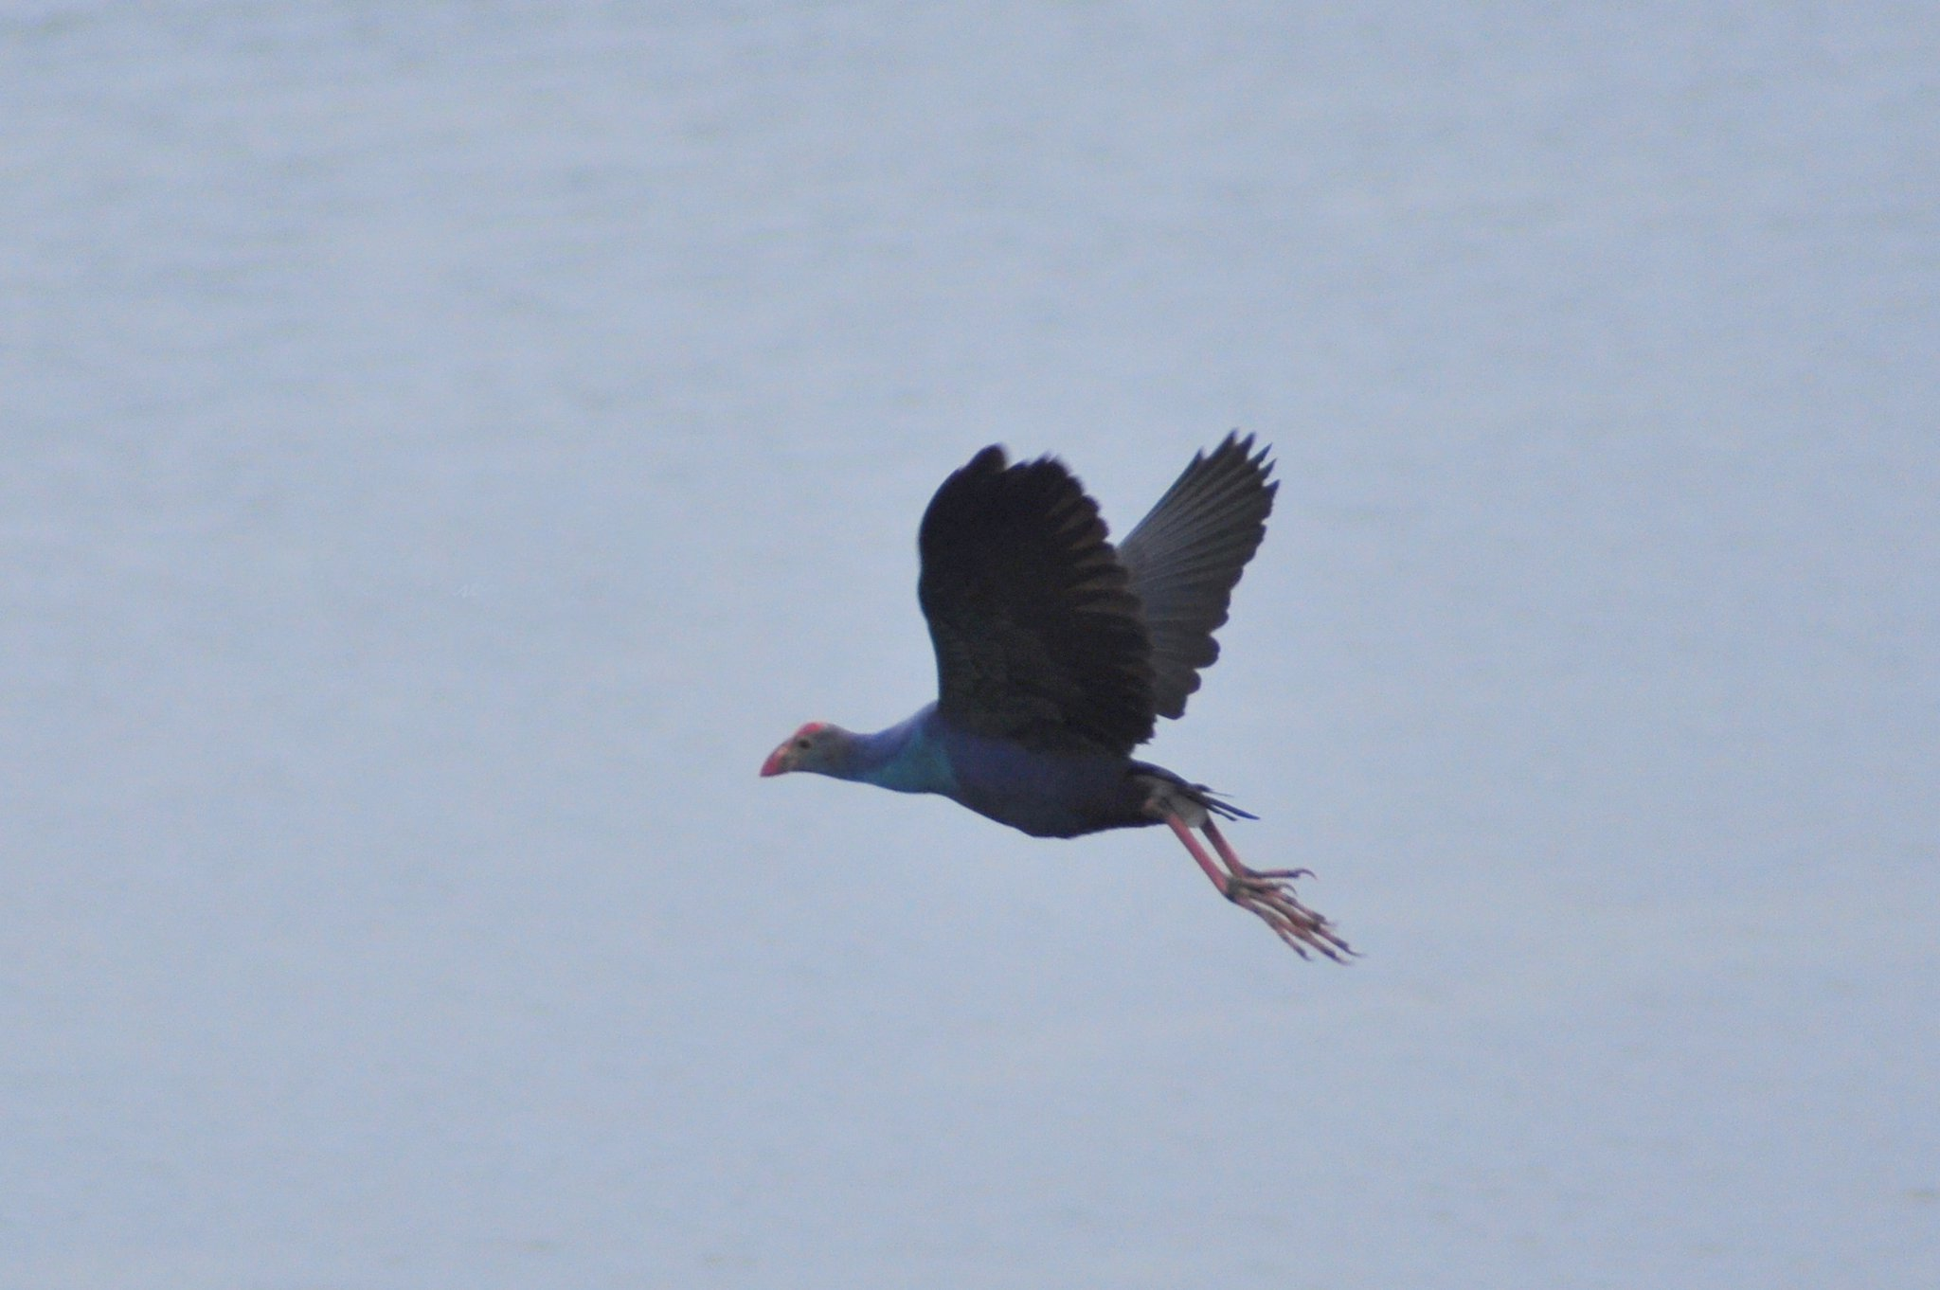
廣東省海豐縣素有“中國水鳥之鄉”之稱，縣內設有面積達11公頃的“廣東海豐鳥類省級自然保護區”，區內的濕地生物多樣性非常豐富，已被接納為「國際重要濕地」之一。 海豐位於國際候鳥途經中國東部沿海地區的重要遷徙路線上，不同類型的濕地生態系統支持和庇護著每年冬季4萬隻以上越冬水鳥，當中包括全球瀕危的黑臉琵鷺和易危的卷羽鵜鶘，以及超過70種屬國家一、二級及省重點保護的鳥種。

活動日期：2013年1月6日(星期日)
行程時間：上午 8時30分正 至 下午約7時
集合時間：08:30
集合地點：深圳羅湖城附近(詳細上車地點待定)
行程： 08:30-10:30 剩專車由深圳至海豐
10:30-17:00 海豐保護區觀鳥 及 午餐 (自備或自費於附近的餐廳)
17:00-19:00 剩專車由海豐回深圳
目標鳥種：水鳥，特別是卷羽鵜鶘及紫水雞
領隊：張浩輝博士
名額：19名 (由於名額有限，只限會員本人參加。)
活動費用：會員 - 港幣$150-
報名：請填妥報名表，連支票寄回本會。

活動當天領隊聯絡電話：852 – 9457 3196
免責聲明
因參與由香港觀鳥會 (下稱“本會”) 主辦的一般活動、戶外觀鳥活動或訓練課程 (下稱“活動”) 所出現的個人或財產的損失、受傷、死亡或損壞，無論是在活動過程中發生或活動完結後出現，本會不會承擔任何財政或其他方面的責任或義務。所有參與上述活動的參加者，必須確保自己的身體狀況能夠適應活動的要求，如有疑問，應該在參與活動前諮詢合資格的醫務人員，本會建議參加者應自行購買相關保險以保障自己。報名參與上述活動的人士即表示同意即使在活動過程中或活動完結後出現的損失、受傷、死亡或損壞，本會的執行委員會委員、其他委員會委員、職員、僱員、義工、中介機構或人員及分判商均不會承擔任何責任。

************************************************************
報 名 表

日期 | 活動地點 | 姓名 (首位參加者為聯絡人) | 會員號碼 | 聯絡電話 | 活動費用
6/1/2013 | 海豐
6/1/2013 | 海豐
6/1/2013 | 海豐
6/1/2013 | 海豐

現付上劃線支票港幣___________元 (支票抬頭：香港觀鳥會) 聯絡人電郵：_________________
申請人： 日期： 簽署：
請將填妥的報名表格連同劃線支票寄：九龍油麻地彌敦道480號 鴻寶商業大廈14樓

Outing to Haifeng Bird Provincial Nature Reserve, Guangdong
Haifeng Bird Provincial Nature Reserve locates in Haifeng, one of counties in Guangdong province, which is also known as "Home of Waterbirds in China". The Nature Reserve has a total area of ​​11,590 hectares and is listed as one of the “Wetlands of International Importance” due to its rich biodiversity. Different types of wetlands found in the Nature Reserve serve as a staging site to support over 40 thousands waterbirds per year when they are migrating via the flyway passing east coast of China. This includes globally “endangered” Black-faced Spoonbill, “vulnerable” Dalmatian Pelican and over 70 species of birds under national or provincial protection.

Outing date: 6/1/2013 Sunday
Activity time: 08:30 - 19:00

Gathering time: 08:30
Gathering place: Luo Hu Comm City, Shenzhen (Exact point to be confirmed)

Details: 08:30-10:30 Coach from Shenzhen to Haifeng
10:30-17:00 Birding at Haifeng NR & Lunch (at your own cost at nearby restaurant)
17:00-19:00 Return coach from Haifeng to Shenzhen

Target Species: Waterbirds, in particular Dalmatian Pelican and Purple Moorhen
Leader: Dr. Cheung Ho Fai
Capacity: 19 participants (Open to HKBWS members only due to limited seating)
Outing fee: Member HK$150-
Registration: please fill out the registration slip & return to our office with a crossed cheque

Leader’s contact for outing date only: 852 – 9457 3196
Disclaimer
The Hong Kong Bird Watching Society (“the HKBWS”) assumes no responsibility, liability or obligations, whether financial or otherwise, for losses, injuries, death, damages, whether to the person or property, arising or occurring in the course or as a result from the activities, outings or training courses (“the Activities”)organized by the HKBWS. Persons who participate in the Activities must ensure that they are medically fit to do so. If in doubt, they should consult qualified medical practitioners before participating. Participants are recommended to purchase relevant insurance for their own protection. By participating in the Activities, the participants impliedly agree that they will not hold the HKBWS, its Executive Committee members, other committee members, its officers, employees, volunteers, agents or subcontractors responsible or liable for any losses, injuries, death damages arising or occurring in the course or as a result from the Activities.

************************************************************
Registration Slip

Date | Outing | Name  (First one considered contact person) | Membership No. | Mobile Phone | Outing fee
6/1/2013 | Haifeng
6/1/2013 | Haifeng
6/1/2013 | Haifeng
6/1/2013 | Haifeng

Enclosed please find a Cheque of HK$ Contact person’s email: ________________________
(Payable to The Hong Kong Bird Watching Society)
Applicant: _ Date: Signature :

Please return this slip together with a crossed cheque to: 14/F, Ruby Commercial Bldg., 480 Nathan Road, Kln.

