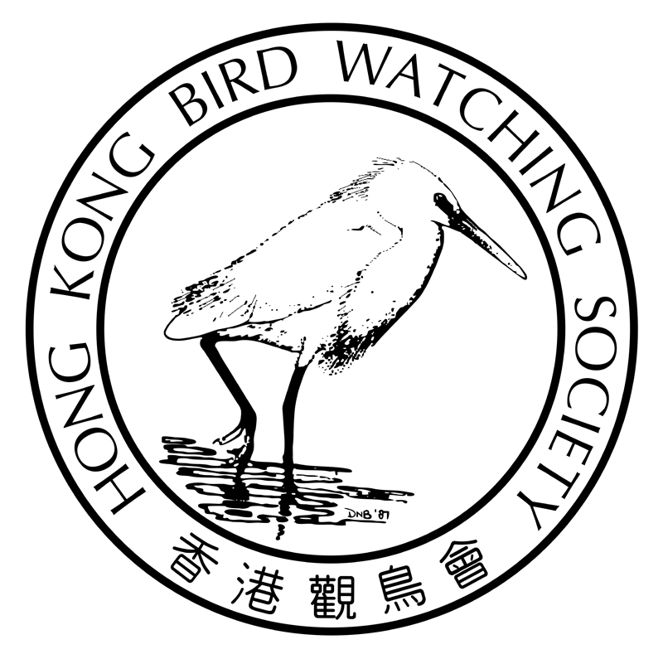

Hong Kong Bird Watching Society
《 Little Little Bird Race ~ Hong Kong Island 》

15 September 2013 (06:00-14:00)

To take a fun challenge and to promote the understanding of birds in different districts, YOU are cordially invited to participate in the “Little Little Bird Race”. You can take a challenge without pressure, and at the same time fill out the bird database for different areas of Hong Kong.

Details of the Race

- Format：Participants are required to form a racing team or being individual to spot, identify & record bird species as many as possible within limited time in Hong Kong Island.
- Date：15 September 2013 (Sunday)
- Time：06:00 to 12:00
- Boundary：Any route and location within Hong Kong Island (including Ap Li Chau) and within visibility.
- Category： 1) Individual - A person who is aged 16 or above, both members and
non-members are welcome.
- Team - 2 to 4 in each team with a minimum of 1 HKBWS member
(no restriction on age).

- Registration Fee： Individual - HKD$50 (Member) / HKD$100 (Non-member)
Team - HKD$100
- Awards：Overall Champion, Individual Champion, Team Champion and 3 Merit Prizes for each category.
- Transportation：Participants are required to arrange their own transportation on race day.
- Insurance：The Society shall have no responsibility, financial or otherwise, for expenditure or other liabilities arising from the Race. Participants are recommended to arrange relevant insurance for their own protection.
- Prize Presentation & Gathering：14:00 to 16:30 on 15 Sep 2013 at HKBWS Lai Chi Kok office. Participants, their family & friends are welcome to join.
- Registration deadline：9 September 2013
Rules
  - Recorded species will be counted either by observation or by heard. For team category, there must be at least TWO of the members agree on identification.
  - Each individual/team may start and end at any locations on the HK Island of their choice.
  - The following restrictions apply during the Race:
    - Attracting birds with audio recordings/facilities or baits are prohibited.
    - Flushing and chasing of birds are strictly prohibited.
  - Record submission:
    - Fill out the “Little Little Bird Race - Logbook” provided by the Society and submit it to our LCK office on or before 14:00 on race day; or
    - Complete records entry to our online Record Submission Webpage on or before 14:00. Link & username will be advised 5 days prior to race day.
(Mobile phone with internet connection is required to access to this webpage. For convenience of race team, 3 sets of computers will also be available at our office from 12:00 to 14:00, on first-come-first-serve basis.)
  - All individual participants and at least one participant of each team are required to arrive at our LCK office on or before 14:00 to attend the prize presentation and gathering. Individuals/teams that do not attend the prize presentation & gathering are not entitled to compete for the merit prizes.
  - All records will be examined by a group of adjudicators. They may, on their own judgment, ignore any unreasonable records or request for more details of the record.
  - All species from Categories I and II of the official bird list will be counted, while those in Category III will be excluded. (Please refer to the latest list: http://www.hkbws.org.hk/BBS/viewthread.php?tid=18619).

Inquiry： Miss Haley Yeung 2377 4387 E-mail: birdrace@hkbws.org.hk
Hong Kong Bird Watching Society
《 Little Little Bird Race ~ Hong Kong Island 》
Registration Form
Categories： | ◻ Individual (Aged 16 or above)  (Parental/Guardian’s Consent Form is required for participant aged below 18.) | ◻ Team (Please fill out Captain’s contact below)  (No age restriction. Parent/Guardian’s Consent Form is required for participant aged below 18.)
Name of  Team Captain： | (Chi) | （Eng） _____
Mobile Phone No.： | E-mail：_______________________________
Membership No.： |  | ◻ Non-member
Address： | ___
Registration fee： | ◻ Individual (Member) HK$50-  ◻ Individual (Non-member) HK$100- |  | ◻ Team HK$100-
Prize Presentation & Gathering:  Donation to HKBWS： | ◻ I/We shall have___________ team member(s) attcending the prize presentation & gathering.  (Each team member can bring ONE friend free of charge; additional ones will be charged at $50/each.)  HK$ ( ◻ Receipt for tax deductible**)  ** Donation of or above $100 is tax deductible
Total Amount： | HK$
 | ◻ Cash ◻ Direct credit to Bank (with receipt)
 | ◻ Cheque (Cheque no. Bank _______________)
Team Information：
Team name： | (Chi) | (Eng)
 |  |  | Age**
Team member： | 1. (Chi) Captain (same as above) | (Eng) Captain (same as above) | 18 or above / below 18 **
 | 2. (Chi) | (Eng) | 18 or above / below 18 **
 | 3. (Chi) | (Eng) | 18 or above / below 18 **
 | 4. (Chi) | (Eng) | 18 or above / below 18 **
(**Parental/Guardian’s Consent Form is required for participant aged below 18)
* Method of payment:
- By cheque payable to “The Hong Kong Bird Watching Society” and send to our office;
- Direct credit to Bank of China (HK) Account Number: 012-878-1-076439-9, then return the receipt with this form to us;
- You can also visit our office in person.
- Office Address: 7C, V Ga Building, 532 Castle Peak Road, Lai Chi Kok, Kowloon, Hong Kong.

Disclaimer
The Hong Kong Bird Watching Society (“the HKBWS”) assumes no responsibility, liability or obligations, whether financial or otherwise, for losses, injuries, death, damages, whether to the person or property, arising or occurring in the course or as a result from the activities, outings or training courses (“the Activities”)organized by the HKBWS. Persons who participate in the Activities must ensure that they are medically fit to do so. If in doubt, they should consult qualified medical practitioners before participating. Participants are recommended to purchase relevant insurance for their own protection. By participating in the Activities, the participants impliedly agree that they will not hold the HKBWS, its Executive Committee members, other committee members, its officers, employees, volunteers, agents or subcontractors responsible or liable for any losses, injuries, death damages arising or occurring in the course or as a result from the Activities.

Hong Kong Bird Watching Society
《 Little Little Bird Race ~ Hong Kong Island 》

Parental/Guardian’s Consent Form

I ,_________________________, parent/guardian of ________________________, has read, understood and agreed upon the arrangement and disclaimer of the Little Little Bird Race held in HK sland on 15 September, 2013 organized by the Hong Kong Bird Watching Society. I freely give my consent to let my child take part in this.
Signature：________________________________________
Full name of parent/guardian：_________________________
Date：_____________________________________________

****************************************************************

Parental/Guardian’s Consent Form

I ,_________________________, parent/guardian of ________________________, has read, understood and agreed upon the arrangement and disclaimer of the Little Little Bird Race held in HK Island on 15 September, 2013 organized by the Hong Kong Bird Watching Society. I freely give my consent to let my child take part in this.
Signature：________________________________________
Full name of parent/guardian：_________________________
Date：_____________________________________________

