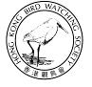
猛 禽 辨 識 工 作 坊
Raptor Identification Workshop

本工作坊特別為「《雀躍薈》- 觀鳥訓練證書課程基礎班」的畢業學員或擁有最少一年觀鳥經驗的鳥友而設的進階課程，旨在鞏固及提升參加者辨認香港常見猛禽的技巧及能力，我們期望學員在完成工作坊後，有能力辨認及解說常見猛禽的主要特徵。除猛禽的辨識外，工作坊內容亦包括猛禽的分類、身體構造 (羽毛及骨骼)及猛禽的遷徙。
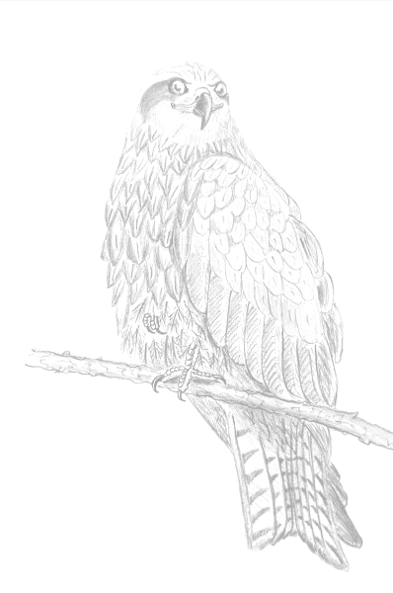
This workshop is an upgrading course for elementary bird watchers who has completed the Elementary Bird Watching Course or has a minimum of 1 year bird watching experience and aims to consolidate and enhance their raptor identification skills. By the end of the workshop, participants should be able to identify and explain the key field marks of common raptors in HK. In addition to identification skills, this workshop also covers topics on raptor’s classification, body structure (feather & bone system) and its migration.

工作坊難度：中級 Level of difficulty: Intermediate

香港常見猛禽Common Raptors in HK:
鶚  Western Osprey | 鳳頭鷹  Crested Goshawk | 紅隼  Common Kestrel | 阿穆爾隼  Amur Falcon
鳳頭蜂鷹  Crested Honey Buzzard | 赤腹鷹  Chinese Sparrowhawk | 燕隼  Eurasian Hobby | 雀鷹  Eurasian Sparrowhawk
黑鳶  Black Kite | 日本松雀鷹 Japanese Sparrowhawk | 遊隼  Peregrine Falcon | 鵲鷂  Pied Harrier
白腹海鵰 White-bellied Sea Eagle | 松雀鷹  Besra | 烏鵰  Greater Spotted Eagle | 黑翅鳶  Black-winged Kite
蛇鵰  Crested Serpent Eagle | 灰臉鵟鷹  Grey-faced Buzzard | 白肩鵰  Eastern Imperial Eagle | 黑冠鵑隼  Black Baza
白腹鷂  Eastern Marsh Harrier | 普通鵟  Eastern Buzzard | 白腹隼鵰  Bonelli's Eagle

導師：陳佳瑋先生 Instructor: Mr. Peter KW Chan

本課程以廣東話教授 This workshop will be taught in Cantonese.

溫馨提示：我們並不能預測猛禽於何時何地出沒，故在戶外考察當日有可能觀察不到預計的猛禽，敬請明白。
A friendly reminder: There might be possibility that expected raptors were not seen on outing day due to their unpredictable and irregular traveling routes. Your understanding would be much appreciated.

報名資格 Requirements：

本課程適合有初級觀鳥水平的人士，報名者亦必須符合以下資格：
- 畢業於本會的《觀鳥訓練證書課程基礎班》，或
擁有最少一年觀鳥經驗，及
- 自備雙筒望遠鏡
本會會員將獲優先取錄。

This workshop is ideal for elementary birdwatchers who:
- have completed the Elementary Bird Watching Course by HKBWS, or
have at least 1 year bird watching experience, and
- got a pair of binocular.
Priority will be given to HKBWS members for registration.

名額No. of enrolment: 15人
費用Course Fee: 會員Member ~ HK$700- 非會員Non-Member ~ HK$1,100-
日期Date:
室內課堂 Lecture:
2013-12-06 (五Fri) 19:00 – 21:30  2013-12-09 (一Mon) 19:00 – 21:30 | 本會辦事處：荔枝角青山道532號偉基大廈7樓C室  HKBWS Office: 7C, V Ga Bldg, 532 Castle Peak Rd, Lai Chi Kok
戶外考察 Outing:
2013-12-08 (日Sun) 08:00 – 13:00  2013-12-15 (日Sun) 09:00 – 14:00 | 米埔自然護理區 Mai Po Nature Reserve  西貢蠔涌 Ho Chung, Sai Kung

查詢 Enquiry：2377 4387 香港觀鳥會辦事處 HKBWS Office

--------------------------------------------------------------------------------------------------------------------

猛禽辨識工作坊 報名表格 (12/2013)
Raptor Identification Workshop: Registration Form (12/2013)

Name 姓名:(中文)________________________（Eng）______________________ Membership No.會員編號:_______________

Mobile Phone手提電話:____________________________ E-mail電郵: ______________________________________________

Address地址:________________________________________________________ 觀鳥年資：_________________________

Course Fee費用：會員HK$700- / 非會員HK$1,100- Payment Method付款方法：Cash 現金 / Cheque支票

Please issue a cheque payable to “The Hong Kong Bird Watching Society” and post to our office together with this registration form.
請附上支票（抬頭【香港觀鳥會】）並與本表格一同寄回本會。

Address: 7C, V Ga Building, 532 Castle Peak Road, Lai Chi Kok, Kowloon
地址：香港九龍荔枝角青山道532號偉基大廈7樓C室 Inquiry查詢: 2377 4387

