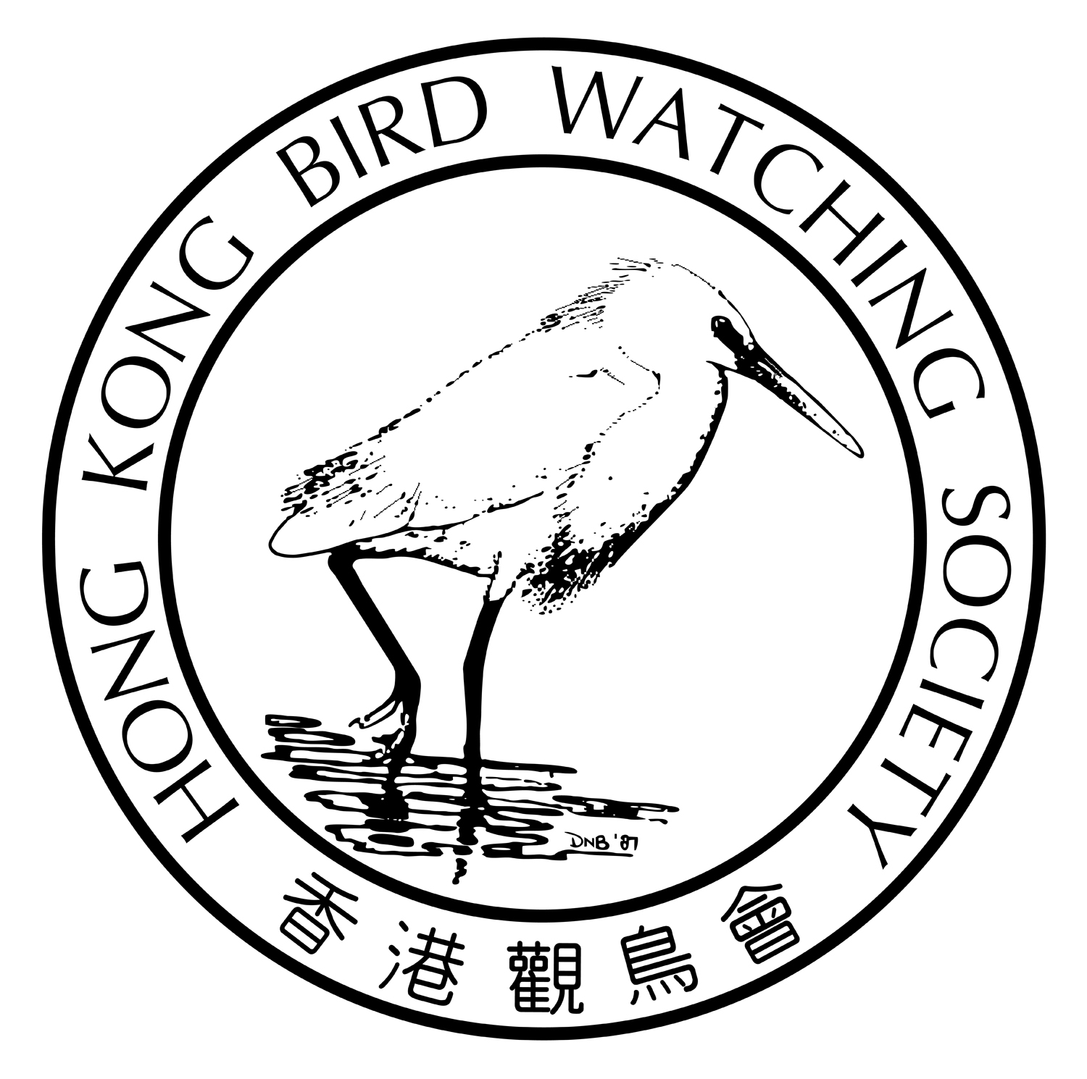
香港觀鳥日
暨
觀鳥比賽籌款活動

2015年3月21及22日

親愛的會員：

2014是否你的｢觀鳥大年｣？ 12月中旬出現的｢栗頭虎斑鳽｣起碼可以獲頒個｢年終大獎｣，至於哪個是你的最愛—｢鴉嘴卷尾｣、｢粉紅山椒鳥｣、｢白頭鵐｣還是｢紫水雞｣並不重要，我最希望頒一項｢終身成就獎｣給蒲台。一年一度的觀鳥比賽又來了，或者你可以考慮到蒲台爭奪｢最佳雀鳥｣的獎盃！

為了鼓勵不同鳥友參與這項年度盛事，本年度的比賽分成三個組別，即｢觀鳥同樂組｣、｢觀鳥新秀組｣，令從未試過觀鳥的新知，或剛剛加入觀鳥行列的鳥友，也可以一嘗觀鳥的樂趣。而喜歡挑戰的你，當然要進入｢公開挑戰組｣，在24小時內盡｢✓｣香港境內所有鳥種！

你的參與更可以推動本會的鳥類保育及生態教育工作繼續向前，鼓勵更多市民加入觀鳥及保育的行列，舉辦更多生態教育活動，令香港的自然生態得以持續，人和鳥可以繼續享受這份大自然的恩賜！

我們誠邀你－
(1) 參加本年度的「香港觀鳥日」活動，同時邀請親朋戚友慷慨贊助；
(2) 贊助你支持的隊員或隊伍；
(3) 直接捐款予本會。

謹代表香港觀鳥會感謝 閣下過去的長期支持，期待你的參與！
您的支持是我們最重要的推動力！
您的支持是我們最重要的推動力！
您的支持是我們最重要的推動力！
您的支持是我們最重要的推動力！
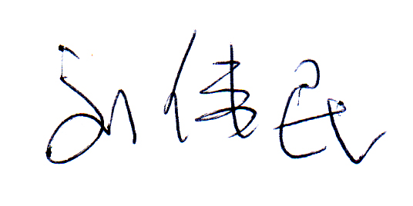
香港觀鳥會主席

劉偉民敬約
2015年1月27日

您的支持是我們最重要的推動力！
活 動 內 容
 | 觀鳥同樂組 | 觀鳥新秀組您 | 公開挑戰組您
活動 形式 | 由專人帶領，到不同生境尋找、辨認及記錄本港境內的野生雀鳥。 | 在指定時間內尋找、辨認及記錄本港境內的野生雀鳥。 | 在指定時間內尋找、辨認及記錄本港境內的野生雀鳥。
對象 | 歡迎沒有觀鳥經驗的人士及一家大小參與，對象不限。 | 歡迎加入觀鳥行列不超過3年的鳥友參與。 | 歡迎任何人士及資深鳥友參與，隊中最少一名為本會會員。
日期 | 2015年3月22日  星期日 | 2015年3月22日  星期日 | 2015年3月21及22日  星期六及日
時間 | 6小時  上午8時至下午2時 | 7.5小時  上午6時至下午1時30分 | 24小時  3月21日中午12時 至  3月22日中午12時
人數 | 每隊人數不限  但同樂組總人數以50位為限，名額先到先得 | 每隊3-5人 | 每隊3-5人
交通  及 路線 | 大會安排旅遊車接載所有參加者，按大會指定路線共同進退。 | A 自行安排；或  B乘搭大會安排的旅遊車，跟隨同樂組路線共同進退。 | 自行安排
領隊 | 專人隨團導賞 | 不適用 | 不適用
起點 | 九龍公園 | A自行安排；或  B九龍公園 | 自行安排
費用 | 報名費每位250元，  包括全日交通接送，  大小同價。 | A 報名費每位200元，  12歲或以下每位150元  B 報名費每位300元，  12歲或以下每位250元，費用包括報名費及交通費 | 報名費每位250元  12歲或以下每位150元
獎項 | (1)隊伍籌款額最高一名 | (1)隊伍籌款額最高一名  (2)觀鳥紀錄最高冠、亞、季軍各一名  (3)最佳雀鳥紀錄一名 | (1)隊伍籌款額最高一名  (2)觀鳥紀錄最高冠、亞、季軍各一名  (3)最佳雀鳥紀錄一名
紀念品 | 每人獲贈紀念T恤及襟章各一，完成活動可獲精美小禮品一份 | (1)每人獲贈紀念T恤及襟章各一，完成比賽可獲頒證書  (2)另設三項獎章，分別為小白鷺、普通翠鳥及黑臉琵鷺，觀鳥紀錄達50、65、80種便可獲不同獎章。 | (1)每人獲贈紀念T恤及襟章各一，完成比賽可獲頒證書  (2)另設三項獎章，分別為小白鷺、普通翠鳥及黑臉琵鷺，觀鳥紀錄達100、110、125種便可獲不同獎章。

- 截止日期：2015年3月4日
- 比賽規則稍後提供
- 聚餐(自助下午茶)及頒獎禮：2015年3月22日下午2時半，詳情另行通知
- 查詢電話：2377 4387

香港觀鳥日
暨
觀鳥比賽籌款活動

報名及籌款表格

致：香港觀鳥會 (傳真號碼：2314 3687 查詢: 2377 4387 電郵: birdrace@hkbws.org.hk)
---------------------------------------------------------------------------------------------------------------------------------------------------------
(1) 我們報名參加2015年｢香港觀鳥日」的  觀鳥同樂組  觀鳥新秀組  公開挑戰組 (請✓)

隊伍名稱：(中文) (英文)
隊長姓名：1) (中文) (英文) |  | 隊長電郵：
隊長電話：(手提) |  | 隊長電郵：
隊員姓名 | 2) (中文) (英文) | 4) (中文) (英文)
隊員姓名 | 3) (中文) (英文) | 5) (中文) (英文)

報名費：每位 $_________________ X _______________ 位 總金額：$_________________________
付款方法： 現金 / 支票 (支票號碼_________________銀行___________________)

(2) 本人未克參與是次活動，但希望捐款支持：
❒ ___________________ (隊伍名稱) 捐款額：(一次過) 港幣$__________或 (每一種鳥) 港幣$____________
❒ 香港觀鳥會的鳥類保育及教育工作：
港幣$1,000 港幣$500 港幣$200 港幣$100 (其他)港幣$__________________

捐款人姓名：______________________________________________________聯絡電話：________________________
捐款人地址：______________________________________________________聯絡電郵：________________________
(*捐款港幣$100或以上可要求本會發出收據作扣減稅款用途，如需要收據請✓ 需要 不需要)

---------------------------------------------------------------------------------------------------------------------------------------------------------

 籌 款 表 格 
贊助人姓名 | 如需收據  請✓ | 贊助金額 | 贊助人姓名 | 如需收據  請✓ | 贊助金額 | 贊助人姓名 | 如需收據  請✓ | 贊助金額

*捐款港幣$100或以上可要求本會發出收據作扣減稅款用途 (請在表格內註明✓)
*此表格可自行複製
*捐款可立即繳交，或最遲於比賽後兩星期內繳交
*繳款辦法： －捐款可以支票繳付，抬頭「香港觀鳥會」 或 「The Hong Kong Bird Watching Society」；
－可將捐款存入本會中國銀行（香港）的戶口：012-878-1-076439-9，再把收據連此表格寄回本會；
－亦可親臨本會以現金或支票繳付。

香港觀鳥會地址：香港九龍荔枝角青山道532號偉基大廈7樓C室
Hong Kong Bird Watching Day
Cum
Bird Race Fundraising Event

21 & 22 March 2015

Was 2014 your “Big Year”? The Japanese Night Heron in mid-December must be the year-end Champion. What about yours? Crow-billed Drongo? Rosy Minivet? Pine Bunting or Purple Swamphen? Instead, I would like to present a “Life Achievement Award” to Po Toi where most of the HK first records of the year were found. The annual bird race is coming soon, maybe you can think about going to Po Toi to get a bird which may be a winning “Bird of the Day”!

In order to encourage different types of birders to join the event, the race is divided into 3 categories. “Fun-fun Team” and “Green Birder Team” may fit new birdwatchers and birdwatchers who have never joined the Bird Race before so that they can enjoy the wonders of birdwatching. As for someone as competitive as yourself, you can join the “Challenger Team” category to check off all the birds within the Hong Kong SAR boundary within 24 hours.

Your participation can surely help promoting the Society’s bird conservation and education work and encourage more citizens to participate in birdwatching and conservation works, including keeping a closer watch on the threats to Hong Kong’s natural environment, carrying out more environmental education activities, so that Hong Kong’s natural environment can be sustained, people and bird can live in harmony so that everyone can enjoy the nature’s gifts!

We invite you to -
(1) Join this year’s Hong Kong Bird Watching Day and invite your friends and family to support you through generous sponsorship;
(2) Sponsor the team member or team you support;
(3) Directly donate to the Society

On behalf of the Hong Kong Bird Watching Society, thank you for your long support and we look forward to your participation!
您的支持是我們最重要的推動力！
您的支持是我們最重要的推動力！
您的支持是我們最重要的推動力！
您的支持是我們最重要的推動力！
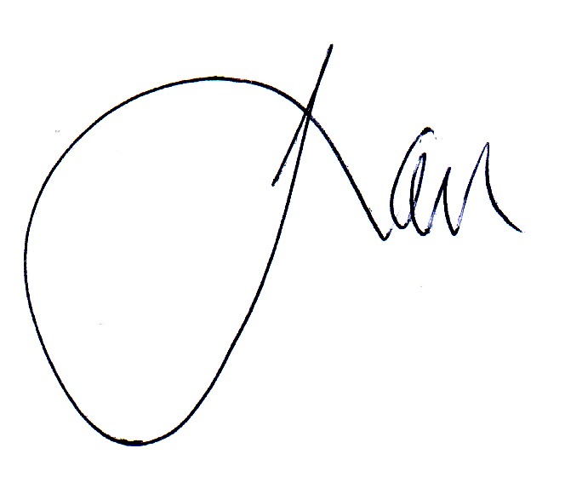
Yours faithfully

Apache Lau
Chairman
Your Support is the Momentum of our Work!
Details of the Event
 | Fun-fun  Team | Green Birder  Team | Challenger  Team  您
Nature of the event | Lead by bird guide to visit various bird watching sites to spot, identify and record bird species as many as possible. | To spot, identify & record bird species as many as possible inside Hong Kong territory. | To spot, identify & record bird species as many as possible inside Hong Kong territory.
Target Participant | People with little or no experience in bird watching or family members are welcome. | Fresh bird watchers with experience no more than 3 years are welcome | All are welcome, and at least one of them is member of the Society.
Date | Sunday  22 Mar 2015 | Sunday  22 Mar 2015 | Saturday & Sunday  21-22 Mar 2015
Time | 6 hrs  8am to 2pm | 7.5 hrs  6am to 1:30pm | 24 hrs  21-22 Mar 2015  (12pm – 12pm)
No. of Team members | No limit for each team  Max. 50 persons for total no. of participants | 3-5 per team | 3-5 per team
Transportation  & route | Coach will be provided along the designated route decided by the organizer. | A Self-serviced ; OR  B Coach & route provided, same as Fun-fun Team. | Self-serviced
Team Leader | Designated guide will be provided by the organizer | N/A | N/A
Starting Point | Kowloon Park | A Self-serviced; OR  B Kowloon Park | Self-serviced
Enrollment Fee | Enrollment fee per PERSON is HK$250-, including the cost of the coach. | A Enrollment fee per PERSON is HK$200- ( $150 for age ≤12yrs)  B Enrollment fee + coach fee per PERSON is HK$300- ( $250 f for age ≤12yrs) | Enrollment fee per PERSON is HK$250- ( $150 for age ≤12yrs)
Prizes | - ONE Highest amount of Donation (per Team) | (1) ONE Highest amount of Donation (per Team)  (2) Highest number of bird species incl 1 Champion, 1 First runner-up & 1 Second-runner up  (4) ONE Best record | (1) ONE Highest amount of Donation (per Team)  (2) Highest number of bird species incl 1 Champion, 1 First runner-up, 1 Second-runner up  (3) ONE Best record
Souvenir | A t-shirt & a batch for each participant. Upon completion of the activity, additional certificate & small gift. | (1) A t-shirt & a batch for each participant, a certificate upon completion of the race  (2) Bird metal pins (Little egret, Common kingfisher & Black-faced spoonbill) will be given if team’s record hit 50, 65 and 80 respectively. | 1) A t-shirt & a batch for each participant, a certificate upon completion of the race  (2) Bird metal pins (Little egret, Common kingfisher & Black-faced spoonbill) will be given if team’s record hit 100, 110 and 125 respectively.

- Deadline of enrollment：4 March 2015
- Regulations of the Bird Race will be provided later
- Gathering (tea buffet) and Prize presentation ceremony：2:30pm, 22 March 2015 (more details will be provided later)
- For enquiry：2377 4387
Hong Kong Bird Watching Day
Cum
Bird Race Fundraising Event

Registration Form & Pledge Form
To: HKBWS Office (Fax: 2314 3687 E-mail: birdrace@hkbws.org.hk Tel: 2377 4387)
---------------------------------------------------------------------------------------------------------------------------------------------------------

- We would like to register in the Hong Kong Bird Watching Day (please ✓)
❑ Fun-fun Team  Green Birder Team  Challenger Team

Name of the Team：(Chi) (Eng)
Name of Team Captain 1)：  (Chi) (Eng) |  | E-mail：
Mobile Phone No： |  | E-mail：
Team Members | 2) (Chi) (Eng) | 4) (Chi) (Eng)
Team Members | 3) (Chi) (Eng) | 5) (Chi) (Eng)

Registration Fee: $______________(per Person) X ____________ Person Total amount: ______________

Payment method: Cash / Cheque (CQ no.____________ / Bank:________________)

(2) I am / We are not able to participate in the event, but would like to donate：
❒ to ____________________________________ (Name of the team) of HK$______________(one-off) OR HK$_________________ (per bird species)
❒ to The Hong Kong Bird Watching Society for organizing more programmes on education and conservation：
HK$1,000  HK $500  HK $200  HK $100 (Others) HK $__________________

Name of Donor:______________________________________ Contact No.: _________________________________
Address of Donor: _____________________________________Email: ____________________________________
(*Donation of or above $100 is tax deductible. Please ✓ appropriately: Receipt needed - No Yes )

---------------------------------------------------------------------------------------------------------------------------------------------------------
 Pledge Form 
Name of Donor | Receipt  (✓) | Amount | Name of Donor | Receipt  (✓) | Amount | Name of Donor | Receipt  (✓) | Amount
*Donation of or above $100 is tax deductible (please put a ✓ in the Receipt box)
*This form could be duplicated if necessary.
*Donation could be paid at your convenience or within two weeks after the Event.
*Method of payment:
－By cheque payable to “The Hong Kong Bird Watching Society” and send to our office;
－Direct credit to Bank of China (HK) Account Number: 012-878-1-076439-9, then return the receipt with this form to us;
－You can also visit our office in person.

*Office Address:：7C, V Ga Building, 532 Castle Peak Road, Lai Chi Kok, Kowloon

