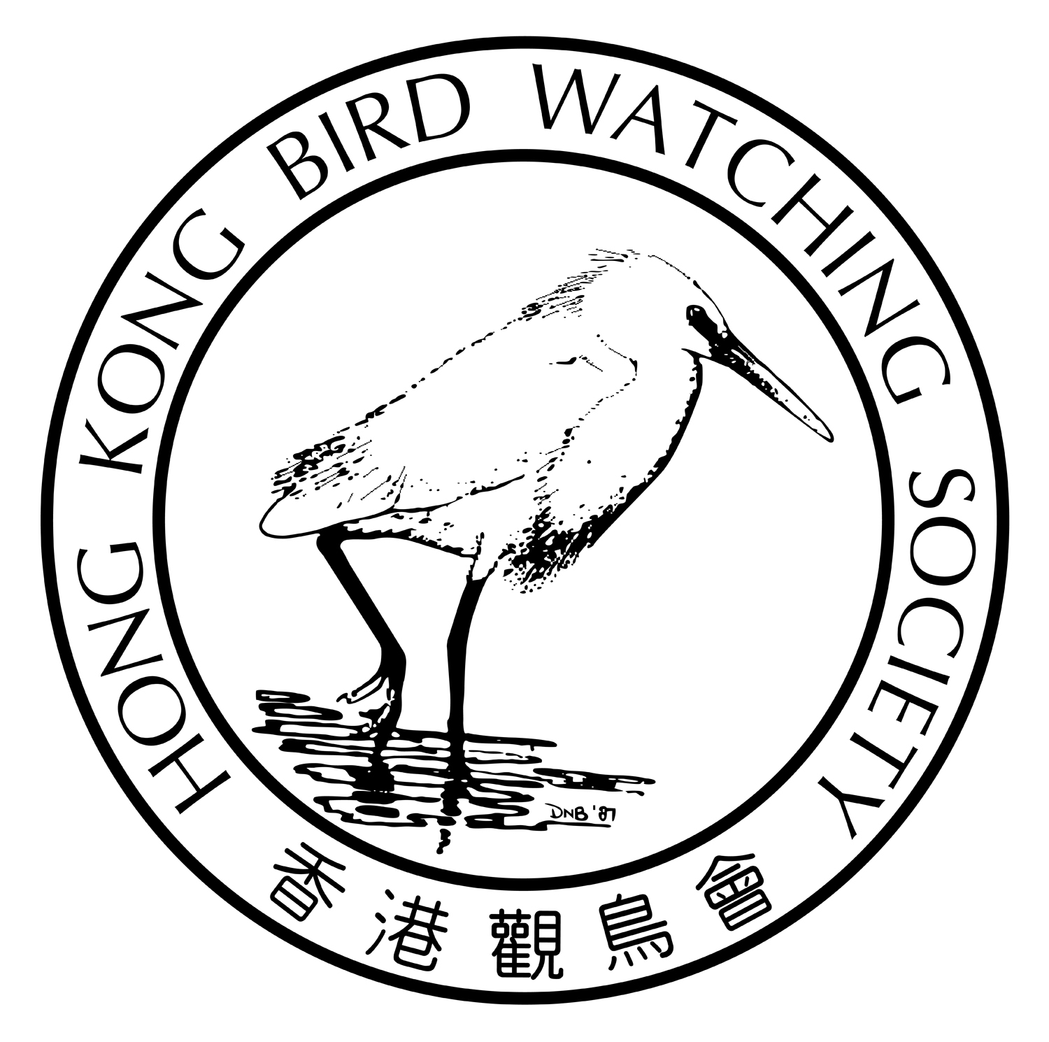
香港觀鳥日
暨
觀鳥比賽籌款活動

2017年4月1及2日

親愛的會員：

2016 有甚麼好雀 ? 塱原各種｢鵐」都有得✓，黃胸、黃喉、黑頭、褐頭、鳳頭、蘆鵐…，只要你肯努力；新田大的小的都有，白額雁、飾胸鷸和靴籬鶯，只要你不怕狗；南丫島那麼遠卻有這麼近的紅喉潛鳥，只要你不怕暈船浪；還有年終大禮闊別14年的白鶴重臨米埔！真是緊張精彩的一年，你收獲又如何呢？ 一年一度的觀鳥比賽又來了，看看你今年的鳥運有多亨通，看看能否✓個最佳雀鳥紀錄回來 !

為了鼓勵不同會員鳥友參與這項年度盛事，本年度的比賽分設兩個組別，即｢公開組｣及｢中學生組｣。｢中學生組｣特為愛好自然生態的中學生而設，在指定路線尋找鳥蹤；而喜歡挑戰的你，可以選擇｢公開組｣，在24小時內盡✓香港境內所有鳥種！

你的參與更可以推動本會的鳥類保育及生態教育工作繼續向前，本年比賽所籌得的款項將用於推動公眾的｢自然教育」工作上，你的支持可以推動我們的工作走得更遠 !

我們誠邀你－

(1) 參加本年度的「香港觀鳥日」活動，同時邀請親朋戚友慷慨贊助；
(2) 贊助你支持的隊員或隊伍；
(3) 直接捐款予本會。

謹代表香港觀鳥會感謝 閣下過去的長期支持，期待你的參與！
您的支持是我們最重要的推動力！
您的支持是我們最重要的推動力！
您的支持是我們最重要的推動力！
您的支持是我們最重要的推動力！
香港觀鳥會主席
劉偉民敬約
2017年1月12日

您的支持是我們最重要的推動力！
活 動 內 容
 | 公開組您 | 中學生組您
活動形式 | 在指定時間內尋找、辨認及  記錄本港境內的野生雀鳥。 | 在指定時間及路線內尋找、辨認  及記錄本港境內的野生雀鳥。
對象 | 歡迎任何人士及資深鳥友參與，  隊中最少一名為本會會員。 | 中學生  （歡迎來自不同學校的同學組隊參加）
日期 | 2017年4月1及2日  星期六及日 | 2016年4月1日  星期六
時間 | 24小時  4月1日中午12時 至  4月2日中午12時 | 7小時  上午8時至下午3時
人數 | 每隊2-5人 | 每隊3-5名中學生  (另必須有1位同行的不參賽  老師/監護人隨隊)
交通及 路線 | 自行安排 | 必須按大會指定路線比賽，  大會提供交通接送  (九龍公園 > 塱原 > 大埔滘)
賽前訓練 | 不適用 | 25/2星期六 | 11/3 星期六
賽前訓練 | 不適用 | 09:00-11:00雀鳥辨識講座
賽前訓練 | 不適用 | 11:00-17:00 九龍公園及塱原戶外觀鳥 | 12:00-15:00  大埔滘戶外觀鳥
費用 | 報名費每位250元  12歲或以下每位150元 | 報名費每隊800元  早鳥優惠(27/1/2017或之前報名)：每隊650元  (費用包括賽前訓練及比賽日三天活動  的交通接送、比賽T恤及紀念品等)
報名截止日期 | 2017年3月10日 | 2017年2月13日
獎項 | (1)隊伍籌款額最高一名  (2)觀鳥紀錄最高冠、亞、季軍各一名  (3)最佳雀鳥紀錄一名 | (1)隊伍籌款額最高一名  (2)觀鳥紀錄最高冠、亞、季軍各一名  (3)最佳雀鳥紀錄一名
紀念品 | (1)每人獲贈紀念T恤及襟章各一，完成比賽可獲頒證書  (2)另設三項獎章，分別為小白鷺、普通翠鳥及黑臉琵鷺，觀鳥紀錄達100、110、125種便可獲不同獎章。 | (1)每人獲贈紀念T恤及襟章各一，完成比賽可獲頒證書  (2)另設三項獎章，分別為小白鷺、普通翠鳥及黑臉琵鷺，觀鳥紀錄達40、50、60種便可獲不同獎章。
頒獎禮 | 2017年4月2日下午  賽後下午茶聚期間  (詳情稍後公佈) | 2017年4月30日  九龍公園『小麻雀嘉年華』期間舉行  (詳情稍後公佈)

- 比賽規則稍後提供
- 下午茶聚及公開挑戰組頒獎禮：2017年4月2日下午2時半，詳情稍後公佈
- 查詢電話：2377 4387
您的支持是我們最重要的推動力！
香港觀鳥日暨 觀鳥比賽籌款活動
報名及籌款表格
致：香港觀鳥會 (傳真號碼：2314 3687 電郵：birdrace@hkbws.org.hk 查詢：2377 4387 )
---------------------------------------------------------------------------------------------------------------------------------------------------------
- 我們報名參加2017年｢香港觀鳥日」的 ( 請✓ )
❑ 公開組

隊伍名稱：(中文) (英文)
隊長姓名：1) |  | 隊長電郵：
 |  | 隊長手提電話：
隊員姓名 | 2) | 4)
隊員姓名 | 3) | 5)

報名費： $____________________ 付款方法：現金 / 支票 (支票號碼_________銀行___________________)

❑ 中學生組

隊伍名稱：(中文) (英文)
中學名稱：
隨隊老師姓名： |  | 電郵： |  | 老師手提電話：
隊員姓名 | 1) |  | 2)
隊員姓名 | 3) |  | 4)
隊員姓名 | 5) |  | ----------------------------------------------------------------

報名費： $____________________ 付款方法：現金 / 支票 (支票號碼_________銀行___________________)

 參 賽 隊 籌 款 表 格 
贊助人姓名 | 如需收據  請✓ | 贊助金額 | 贊助人姓名 | 如需收據  請✓ | 贊助金額 | 贊助人姓名 | 如需收據  請✓ | 贊助金額
*捐款港幣$100或以上可要求本會發出收據作扣減稅款用途 (請在表格內註明✓)

(2) 本校未克參與是次活動，但希望捐款支持： 捐款金額：HK$______________________________

捐款人姓名：________________________________________ 聯絡電郵：__________________________________
捐款人地址：_____________________________________________________聯絡電話：________________________
(*捐款港幣$100或以上可要求本會發出收據作扣減稅款用途，如需要收據請✓ 需要 不需要)

*此表格可自行複製
*繳款辦法： －捐款可以支票繳付，抬頭「香港觀鳥會」 或 「The Hong Kong Bird Watching Society」；
－可將捐款存入本會中國銀行（香港）的戶口：012-878-1-076439-9，再把收據連此表格寄回本會；
－亦可親臨本會以現金或支票繳付。

香港觀鳥會地址：香港九龍荔枝角青山道532號偉基大廈7樓C室
Hong Kong Bird Watching Day
Cum
Bird Race Fundraising Event

1 & 2 April 2017

What birds have you ticked in 2016? Long Valley had a wide selection of buntings, YBB, YTB, BHB, CB & RB. San Tin was a fun place to meet the big guys, GWF gooses, and also the small babies like BB sandpiper and Booted warbler. Lamma had a rare visitor, RT Loon, who stayed briefly on the island in Spring. But don’t forget the year-end bonus and super star, Siberian crane, after a desperate waiting for 14 years! What a year it was! And how was yours? Our annual bird race is coming soon, so let's see how your bird luck is in 2017. Perhaps you’ll be lucky enough to win our best record award!

In order to encourage different types of birders to join the event, the race is divided into 2 categories. “Secondary School Team” category is designated for secondary school students who are nature lovers. As for someone as competitive as yourself, you can join the “Challenger Team” category to check off all the birds within the Hong Kong SAR boundary within 24 hours.

Your participation can surely help promoting the Society’s bird conservation and education work. Fund raised from this bird race will be used for promoting ‘Natue Education’ to the public. Your support serves as a green light for us to go further and work better.

We invite you to -

(1) Join this year’s Hong Kong Bird Watching Day and invite your friends and family to support you through generous sponsorship;
(2) Sponsor the team member or team you support;
(3) Directly donate to the Society

On behalf of the Hong Kong Bird Watching Society, thank you for your long support and we look forward to your participation!
您的支持是我們最重要的推動力！
您的支持是我們最重要的推動力！
您的支持是我們最重要的推動力！
您的支持是我們最重要的推動力！
Yours faithfully

Apache Lau
Chairman

Your Support is the Momentum of our Work!
Details of the Event

 | Challenger  Team  您 | Secondary School  Team
Nature of the event | To spot, identify & record bird species as many as possible inside Hong Kong territory. | To spot, identify & record bird species as many as possible in the designated route and time.
Target Participant | All are welcome, and at least one of them is member of the Society. | Secondary school students
Date | Saturday & Sunday  1-2 April 2017 | Saturday  1 April 2016
Time | 24 hrs  12pm – 12pm, 1-2 April 2017 | 7 hrs  8am to 3pm
No. of Team members | 2-5 per team | 3-5 per team  (with 1 attending teacher or guardian  who doesn’t involve in the race)
Transportation  & route | Self-serviced | Coach & route provided  (Kowloon Park > Long Valley > Tai Po Kau)
Pre-race Training | n/a | Sat 25/2 | Sat 11/3
Pre-race Training | n/a | 09:00-11:00 Bird Identification Talk
Pre-race Training | n/a | 11:00-17:00 Kowloon Park & Long Valley Outing | 12:00-15:00  Tai Po Kau Outing
Enrollment Fee | HK$250- per person  HK$150 for children below12 yrs old | HK$800-per team  Early Bird (on or before 27/1/2017)：  HK$650-per team  (Including cost of pre-race training,  coaches for 3 days, race tee & souvenirs)
Deadline of enrollment | 10 March 2017 | 13 February 2017
Prizes | (1) ONE Highest amount of Donation (per Team)  (2) Highest number of bird species incl 1 Champion,  1 First runner-up, 1 Second-runner up  (3) ONE Best record | (1) ONE Highest amount of Donation (per Team)  (2) Highest number of bird species incl 1 Champion,  1 First runner-up, 1 Second-runner up  (3) ONE Best record
Souvenir | (1) A t-shirt & a batch for each participant, a certificate upon completion of the race  (2) Bird metal pins (Little egret, Common kingfisher & Black-faced spoonbill) will be given if team’s record hit 100, 110 and 125 respectively. | (1) A t-shirt & a batch for each participant, a certificate upon completion of the race  (2) Bird metal pins (Little egret, Common kingfisher & Black-faced spoonbill) will be given if team’s record hit 40, 50 and 60 respectively.
Prize presentation ceremony | 2 April 2017 Afternoon  during gathering after the race  (Details to be announced later) | 30 April 2016  during “Little Sparrow Carnival” at Kowloon Park  (Details to be announced later)

- Regulations of the Bird Race will be provided later
- Tea time gathering and prize presentation ceremony for Challenger Team：2:30pm, 2 April 2017 (details to be announced later)
- For enquiry：2377 4387
Hong Kong Bird Watching Day
Cum Bird Race Fundraising Event

Registration Form & Pledge Form
To: HKBWS Office (Fax: 2314 3687 E-mail: birdrace@hkbws.org.hk Tel for Enquriy: 2377 4387)
---------------------------------------------------------------------------------------------------------------------------------------------------------
- We would like to register in the Hong Kong Bird Watching Day 2017 (please ✓)
❑ CHALLENGER TEAM
Name of the Team：(Chi) (Eng)
Name of Team Captain 1)： |  | E-mail：
 |  | Mobile Phone No：
Team Members | 2) | 4)
Team Members | 3) | 5)

Registration Fee: ___________________ Payment method: Cash / Cheque (CQ no.__________ / Bank:_________)

❑ SECONDARY SCHOOL TEAM
Name of the Team：(Chi) (Eng)
School Name： |  | Teacher’s E-mail：
Name of Attending Teacher/Guardian： |  | Teacher’s Mobile No：
Student  Team Members | 1) | 2)
Student  Team Members | 3) | 4)
Student  Team Members | 5) | ----------------------------------------------------------------

Registration Fee: ___________________ Payment method: Cash / Cheque (CQ no.__________ / Bank:_________)

 Pledge Form for Race Team 
Name of Donor | Receipt  (✓) | Amount | Name of Donor | Receipt  (✓) | Amount | Name of Donor | Receipt  (✓) | Amount
*Donation of or above $100 is tax deductible (please put a ✓ in the Receipt box)

- I am / We are not able to participate in the event, but would like to make a donation of HK$_____________________
to The Hong Kong Bird Watching Society for organizing more programmes on education and conservation.

Name of Donor:______________________________________________ Contact No.: _________________________________

Address of Donor: ____________________________________________Email: ____________________________________
(*Donation of or above $100 is tax deductible. Please ✓ appropriately: Receipt needed - No Yes )
---------------------------------------------------------------------------------------------------------------------------------------------------------
*This form could be duplicated if necessary.
*Method of payment:
－By cheque payable to “The Hong Kong Bird Watching Society” and post to our office;
－Direct credit to Bank of China (HK) Account Number: 012-878-1-076439-9, then return the deposit slip with this form to us;
－You can also visit our office in person for cash payment.
*Office Address:：7C, V Ga Building, 532 Castle Peak Road, Lai Chi Kok, Kowloon

