香港觀鳥會 水鳥(涉禽)辨識課程
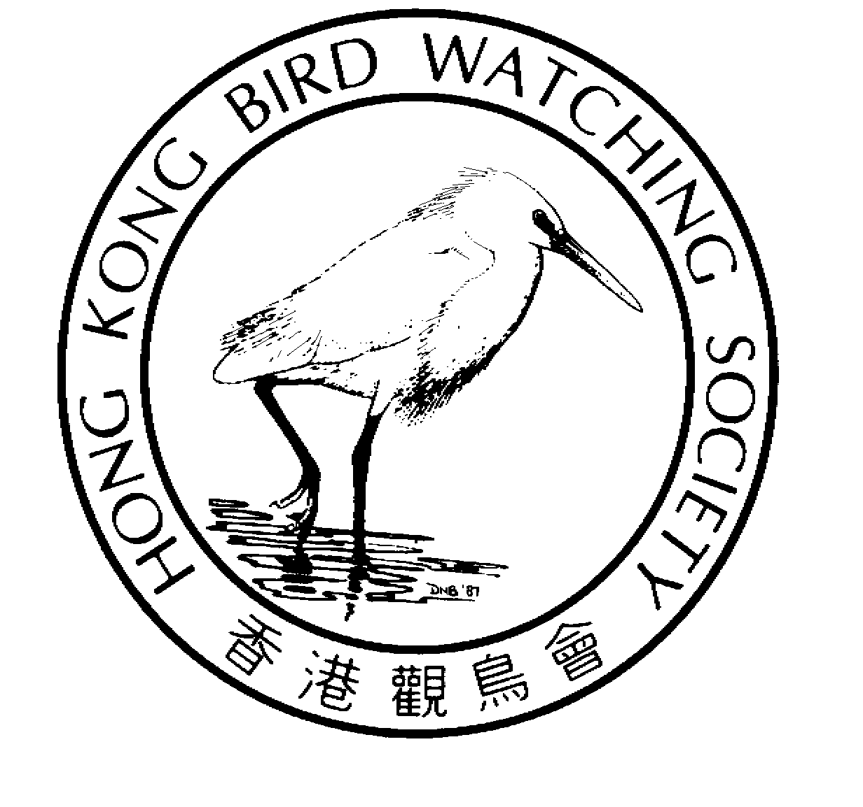
A HKBWS course in Wader Identification

本課程旨在為具中等觀鳥水平的人士而設，我們期望學員在課程完畢後，能夠辨認及拍攝大約45種在香港經過的春季遷徙鳥，學員亦應該可以辨認及解釋這些水鳥的重要特徵。

This course is for intermediate bird watchers. By the end of the course, participants should have watched and photographed about 45 species of wader in Hong Kong during the spring passage period. They should be able to identify these species and explain the most important field marks.

目標涉禽 List of targeted wader:

彩鷸 Greater Painted-snipe
黑翅長腳鷸 Black-winged Stilt
反嘴鷸 Pied Avocet
普通燕鴴 Oriental Pratincole
灰頭麥雞 Grey-headed Lapwing
金斑鴴 Pacific Golden Plover
灰斑鴴 Grey Plover
金眶鴴 Little Ringed Plover
環頸鴴 Kentish Plover
蒙古沙鴴 Lesser Sand Plover
鐵嘴沙鴴 Greater Sand Plover
黑尾塍鷸 Black-tailed Godwit
斑尾塍鷸 Bar-tailed Godwit
中杓鷸 Whimbrel
白腰杓鷸 Eurasian Curlew
紅腰杓鷸 Far Eastern Curlew
鶴鷸 Spotted Redshank
紅腳鷸 Common Redshank
澤鷸 Marsh Sandpiper
青腳鷸 Common Greenshank
小青腳鷸 Nordmann's Greenshank
白腰草鷸 Green Sandpiper
林鷸 Wood Sandpiper
翹嘴鷸 Terek Sandpiper
磯鷸 Common Sandpiper
灰尾漂鷸 Grey-tailed Tattler
翻石鷸 Ruddy Turnstone
紅頸瓣蹼鷸 Red-necked Phalarope
針尾/大沙錐 Pintail/Swinhoe’s Snipe
扇尾沙錐 Common Snipe
長嘴半蹼鷸 Long-billed Dowitcher
半蹼鷸 Asian Dowitcher
紅腹濱鷸 Red Knot
大濱鷸 Great Knot
三趾濱鷸 Sanderling
紅頸濱鷸 Red-necked Stint
小濱鷸 Little Stint
青腳濱鷸 Temminck’s Stint
長趾濱鷸 Long-toed Stint
斑胸濱鷸 Pectoral Sandpiper
尖尾濱鷸 Sharp-tailed Sandpiper
黑腹濱鷸 Dunlin
彎嘴濱鷸 Curlew Sandpiper
勺嘴鷸 Spoon-billed Sandpiper
闊嘴鷸 Broad-billed Sandpiper
流蘇鷸 Ruff

報名資格 Minimum Requirements：
本課程適合有中等觀鳥水平的人士，報名者亦必須符合以下資格：
- 參加者必須加入香港觀鳥兩年或以上，並且仍然具有會員資格；
- 一具良好的單筒望遠鏡(最少放大20倍)及腳架；
- 一具數碼攝影機，並能接駁至單筒望遠鏡作拍攝用，或一部良好的數碼單鏡反光機(400mm/f5.6或以上)；
- 進入米埔保護區及邊境(俗稱浮橋)的個人禁區紙；
- 良好體魄，能夠一天步行10公里，並同時攜帶所有設備。
請考慮清楚是否具備以上條件，未能符合任何一條件者將不會取錄。
1/2
This course is for intermediate birdwatchers. Participants are required to have:
- At least 2 full-year HKBWS membership and presently a member;
- A good telescope (at least 20x) with good tripod;
- A digital camera that can adapt to the telescope or a good DSLR camera (400mm / f5.6 or better);
- Entrance permit to Mai Po and Mai Po boardwalk;
- Good health and strength to walk up to 10 km in a day carrying all the equipment.

Please check the requirement carefully. Applicants who do not satisfy these requirements will be rejected!

名額No. of enrolment: 20人
費用Registration Fee: $1,000

日期Date:
21/3/2009 星期六下午Sat. afternoon 29/3/2009 星期日全天Sun. whole day
5/4/2009 星期日全天Sun. whole day 12/4/2009 星期日全天Sun. whole day
19/4/2009 星期日全天Sun. whole day 1/5/2009 星期五全天Fri. whole day

實習地點Venue of Outing: 塱原(21/3) 及 米埔 Long Valley (21/3) & Maipo
集合地點 Gathering Place: 燕崗遊樂場 及 米埔停車場
Playground of Yin Kong, Sheung Shui & Mai Po car park
交通 Travelling: 自行安排前往及離開 No transportation will be arranged for entering and leaving.
授課語言Language: 中英文 Bilingual (Chinese / English)
查詢 Enquiry：2377 4387 香港觀鳥會辦事處 HKBWS Office

本課程不設戶內講座，所有戶外實習均由資深觀鳥者擔任，首席導師為張浩輝博士；最後一次實習將會測試參加者的表現，表現合格將獲頒發證書乙張。
This course does not have indoor meeting. There will be six outings led by well-qualified instructors. The principal instructor is Dr. HF Cheung. The performance of the participants will be examined in the last outing. A certificate will be issued at the satisfactory completion of the course.
-----------------------------------------------------------------------------------------------------------

香港觀鳥會水鳥(涉禽)辨識課程 報名表格
A HKBWS course in Wader Identification Registration Form

Name 姓名:(中文)________________________（Eng）______________________ Contact No.聯絡電話.: ________________________

Mobile Phone手提電話:_________________E-mail電郵: ____________________________ Membership No.會員編號:_____________

Address地址:____________________________________________________________________________

Please make cheque (payable to “The Hong Kong Bird Watching Society Limited”) and sent with this form to our office.
請附上支票（抬頭【香港觀鳥會有限公司】）並與本表格一同寄回本會。

Address: 14/F., Ruby Commercial Centre, 480 Nathan Road, Kowloon
地址：九龍彌敦道480號鴻寶商業大廈14樓 Inquiry查詢: 2377 4387

2/2

