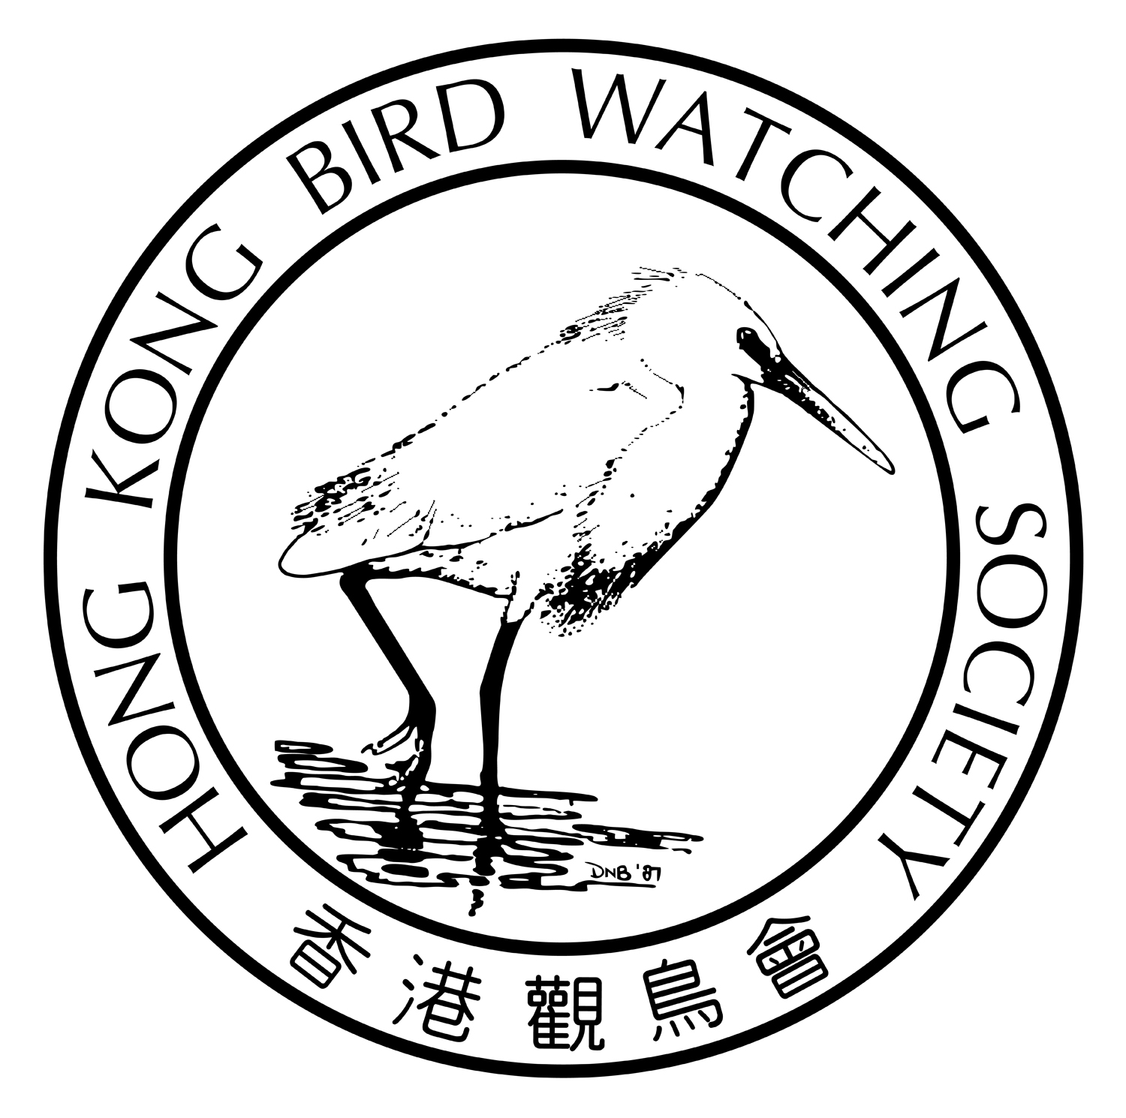
香港觀鳥日
暨
觀鳥比賽籌款活動

2018年2月24及25日

親愛的會員：

經過炎夏一輪的休養生息，秋爽的季節尚未完全開展，南遷的鳥兒已急不及待的降臨 ~豆雁、白額雁、黑鸛、禿鼻烏鴉、赭紅尾鴝、葦鵐、家麻雀 … 差不多同一時間到來，真令人目不暇，而你都✓了嗎 ?

一年一度的觀鳥比賽又來了，今年我們嘗試搞搞新意思，把比賽定於2月下旬舉行，換了時間，又看看大家的成續如何 ! 為了鼓勵不同會員鳥友參與這項年度盛事，本年度的比賽除了特為有觀鳥經驗的會員及鳥友而設的｢公開組｣外，新增｢親子組｣以讓小朋友在家長的引領下、在遊樂中認識雀鳥及其生態，啟發珍愛大自然的思維，｢親子組」賽前訓練更邀請得本會執委黃志俊先生負責帶領。

你的參與更可以推動本會的鳥類保育及生態教育工作繼續向前，本年比賽所籌得的款項將用於推動公眾的｢自然教育」工作上，你的支持可以推動我們的工作走得更遠 !

我們誠邀你－

(1) 參加本年度的「香港觀鳥日」活動，同時邀請親朋戚友慷慨贊助；
(2) 贊助你支持的隊員或隊伍；
(3) 直接捐款予本會。

謹代表香港觀鳥會感謝 閣下過去的長期支持，期待你的參與！
您的支持是我們最重要的推動力！
您的支持是我們最重要的推動力！
您的支持是我們最重要的推動力！
您的支持是我們最重要的推動力！
香港觀鳥會主席
劉偉民敬約
2017年11月20日

您的支持是我們最重要的推動力！
活 動 內 容
 | 公開組您 | 親子組您
活動形式 | 在指定時間內尋找、辨認及  記錄本港境內的野生雀鳥。 | 通過親子的活動，讓小朋友於  遊樂中認識雀鳥、珍愛大自然。
對象 | 歡迎任何人士及資深鳥友參與，  隊中最少一名為本會會員。 | 親子
日期 | 2018年2月24及25日  星期六及日 | 2018年2月25日  星期日
時間 | 24小時  2月24日中午12時 至  2月25日中午12時 | 5小時  上午7時至下午12時
人數 | 每隊2-5人 | 每隊3-5人，必需包括  1位家長(18歲或以上)，及  1位小朋友(4至12歲)
交通及 路線 | 自行安排 | 自行安排
賽前訓練 | 不適用 | 2018年2月3日星期六  下午1時30分至6時  課堂及戶外考察地點：塱原
費用 | 報名費每位250元  12歲或以下每位150元 | 報名費每隊800元  (費用包括賽前訓練、比賽T恤及紀念品等)
報名截止日期 | 2018年2月1日 | 2018年1月26日
獎項 | (1)隊伍籌款額最高一名  (2)觀鳥紀錄最高冠、亞、季軍各一名  (3)最佳雀鳥紀錄一名 | (1)隊伍籌款額最高一名  (2)觀鳥紀錄最高冠、亞、季軍各一名  (3)最佳雀鳥紀錄一名
紀念品 | (1)每人獲贈紀念T恤及襟章各一，完成比賽可獲頒證書  (2)另設三項獎章，分別為小白鷺、普通翠鳥及黑臉琵鷺，觀鳥紀錄達100、110、125種便可獲不同獎章。 | (1)每人獲贈紀念T恤及襟章各一，完成比賽可獲頒證書  (2)另設三項獎章，分別為小白鷺、普通翠鳥及黑臉琵鷺，觀鳥紀錄達40、50、60種便可獲不同獎章。
頒獎禮 | 2018年2月25日下午  賽後下午茶聚期間 | 2018年2月25日下午  賽後下午茶聚期間

- 比賽規則稍後提供
- 下午茶聚及頒獎禮時間及地點：2018年2月25日下午2時半 / 本會辦事處
- 查詢電話：2377 4387
您的支持是我們最重要的推動力！
香港觀鳥日暨 觀鳥比賽籌款活動
報名及籌款表格
致：香港觀鳥會 (傳真號碼：2314 3687 電郵：birdrace@hkbws.org.hk 查詢：2377 4387 )
---------------------------------------------------------------------------------------------------------------------------------------------------------
- 我們報名參加2018年｢香港觀鳥日」的 ( 請✓ )
❑ 公開組

隊伍名稱：(中文) (英文)
隊長姓名：1) |  | 隊長電郵：
 |  | 隊長手提電話：
隊員姓名 | 2) | 4)
隊員姓名 | 3) | 5)

報名費： $____________________ 付款方法：現金 / 支票 (支票號碼_________銀行___________________)

❑ 親子組
隊伍名稱：(中文) (英文)
隊長姓名：1)  ( >18歲) |  |  | 隊長電郵：
 |  |  | 隊長手提電話：
隊員姓名 | 2) | □ 4-12歲  □ >18歲 | 4) | □ 4-12歲  □ >18歲
隊員姓名 | 3) | □ 4-12歲  □ >18歲 | 5) | □ 4-12歲  □ >18歲

報名費： $____________________ 付款方法：現金 / 支票 (支票號碼_________銀行___________________)

 參 賽 隊 籌 款 表 格 
贊助人姓名 | 如需收據  請✓ | 贊助金額 | 贊助人姓名 | 如需收據  請✓ | 贊助金額 | 贊助人姓名 | 如需收據  請✓ | 贊助金額
*捐款港幣$100或以上可要求本會發出收據作扣減稅款用途 (請在表格內註明✓)

(2) 本校未克參與是次活動，但希望捐款支持： 捐款金額：HK$______________________________

捐款人姓名：________________________________________ 聯絡電郵：__________________________________
捐款人地址：_____________________________________________________聯絡電話：________________________
(*捐款港幣$100或以上可要求本會發出收據作扣減稅款用途，如需要收據請✓ 需要 不需要)

*此表格可自行複製
*繳款辦法： －捐款可以支票繳付，抬頭「香港觀鳥會」 或 「The Hong Kong Bird Watching Society」；
－可將捐款存入本會中國銀行（香港）的戶口：012-878-1-076439-9，再把收據連此表格寄回本會；
－亦可親臨本會以現金或支票繳付。

香港觀鳥會地址：香港九龍荔枝角青山道532號偉基大廈7樓C室
Hong Kong Bird Watching Day
Cum
Bird Race Fundraising Event

24-25 February 2017

After a long rest over the hot summer, migratory birds have started their southbound journey even though the cool dry days of autumn have not yet arrived. It is awe-inspiring to see Bean Goose, Greater White-fronted Goose, Black Stork, Rook, Black Redstart, Pallas's Reed Bunting, House Sparrow…. arriving almost at the same time. Have you got your new ticks yet?

The annual bird race is just around the corner. This year, we would like to do it differently. By advancing the dates to late February, we wonder how well the birding teams will be doing. In order to encourage more members to join this annual event, apart from the “Challenger Team” for experienced members and birders, we have added a “Family Team”” to the race so that children can learn more about birds and their habitat under the guidance of their parents. It is hoped that more children can be inspired to treasure the beauty of nature. The pre-race training for the “Family Team” will be conducted by one of our Executive Committee Members, Mr. Dickson Wong.

Your participation can surely help promoting the Society’s bird conservation and education work. Fund raised from this bird race will be used for promoting ‘Natue Education’ to the public. Your support serves as a green light for us to go further and work better.

We invite you to -

(1) Join this year’s Hong Kong Bird Watching Day and invite your friends and family to support you through generous sponsorship;
(2) Sponsor the team member or team you support;
(3) Directly donate to the Society

On behalf of the Hong Kong Bird Watching Society, thank you for your long support and we look forward to your participation!
您的支持是我們最重要的推動力！
您的支持是我們最重要的推動力！
您的支持是我們最重要的推動力！
您的支持是我們最重要的推動力！
Yours faithfully

Apache Lau
Chairman

Your Support is the Momentum of our Work!
Details of the Event

 | Challenger  Team  您 | Family  Team
Nature of the event | To spot, identify & record bird species as many as possible inside Hong Kong territory. | Through parent-child activities, children can learn more about birds and to cherish the beauty of nature while having fun in the company of their parents.
Target Participant | All are welcome, and at least one of them is member of the Society. | Parents & children
Date | Saturday & Sunday  24-25 February 2018 | Sunday  25 February 2018
Time | 24 hrs  12nn – 12nn  24-25 February 2018 | 5 hrs  7am to 12nn
No. of Team members | 2-5 per team | 3-5 per team, including  1 adult (>18yrs) & 1 child (4-12 yrs)
Transportation  & route | Self-serviced | Self-serviced
Pre-race Training | n/a | Sat 3 February 2018
Pre-race Training | n/a | 1:30pm to 6pm
Pre-race Training | n/a | Lecture & outing at Long Valley
Enrollment Fee | HK$250- per person  HK$150 for children below12 yrs old | HK$800-per team  (Including cost of pre-race training,  race tee & souvenirs)
Deadline of enrollment | 1 February 2018 | 26 January 2018
Prizes | (1) ONE Highest amount of Donation (per Team)  (2) Highest number of bird species incl 1 Champion,  1 First runner-up, 1 Second-runner up  (3) ONE Best record | (1) ONE Highest amount of Donation (per Team)  (2) Highest number of bird species incl 1 Champion,  1 First runner-up, 1 Second-runner up  (3) ONE Best record
Souvenir | (1) A t-shirt & a batch for each participant, a certificate upon completion of the race  (2) Bird metal pins (Little egret, Common kingfisher & Black-faced spoonbill) will be given if team’s record hit 100, 110 and 125 respectively. | (1) A t-shirt & a batch for each participant, a certificate upon completion of the race  (2) Bird metal pins (Little egret, Common kingfisher & Black-faced spoonbill) will be given if team’s record hit 40, 50 and 60 respectively.
Prize presentation ceremony | 25 February 2018 afternoon  During tea time gathering after the race | 25 February 2018 afternoon  During tea time gathering after the race

- Regulations of the Bird Race will be provided later
- Tea time gathering and prize presentation ceremony: 2:30pm, 25 February 2018 at HKBWS Office
- For enquiry：2377 4387
Hong Kong Bird Watching Day
Cum Bird Race Fundraising Event

Registration Form & Pledge Form
To: HKBWS Office (Fax: 2314 3687 E-mail: birdrace@hkbws.org.hk Tel for Enquriy: 2377 4387)
---------------------------------------------------------------------------------------------------------------------------------------------------------
- We would like to register in the Hong Kong Bird Watching Day 2018 (please ✓)
❑ CHALLENGER TEAM
Name of the Team：(Chi) (Eng)
Name of Team Captain 1)： |  | E-mail：
 |  | Mobile Phone No：
Team Members | 2) | 4)
Team Members | 3) | 5)

Registration Fee: ___________________ Payment method: Cash / Cheque (CQ no.__________ / Bank:_________)

❑ FAMILY TEAM
Name of the Team：(Chi) (Eng)
Name of Team Captain 1)：  (>18yrs) |  |  | Captain’s E-mail：
 |  |  | Captain’s Mobile No：
Team Members | 2) | □ 4-12yrs  □ >18yrs | 4) | □ 4-12yrs  □ >18yrs
Team Members | 3) | □ 4-12yrs  □ >18yrs | 5) | □ 4-12yrs  □ >18yrs

Registration Fee: ___________________ Payment method: Cash / Cheque (CQ no.__________ / Bank:_________)

 Pledge Form for Race Team 
Name of Donor | Receipt  (✓) | Amount | Name of Donor | Receipt  (✓) | Amount | Name of Donor | Receipt  (✓) | Amount
*Donation of or above $100 is tax deductible (please put a ✓ in the Receipt box)

- I am / We are not able to participate in the event, but would like to make a donation of HK$_____________________
to The Hong Kong Bird Watching Society for organizing more programs on education and conservation.

Name of Donor:______________________________________________ Contact No.: _________________________________

Address of Donor: ____________________________________________Email: ____________________________________
(*Donation of or above $100 is tax deductible. Please ✓ appropriately: Receipt needed - No Yes )
---------------------------------------------------------------------------------------------------------------------------------------------------------
*This form could be duplicated if necessary.
*Method of payment:
－By cheque payable to “The Hong Kong Bird Watching Society” and post to our office;
－Direct credit to Bank of China (HK) Account Number: 012-878-1-076439-9, then return the deposit slip with this form to us;
－You can also visit our office in person for cash payment.
*Office Address:：7C, V Ga Building, 532 Castle Peak Road, Lai Chi Kok, Kowloon

