鷺鳥林普查訓練工作坊2009
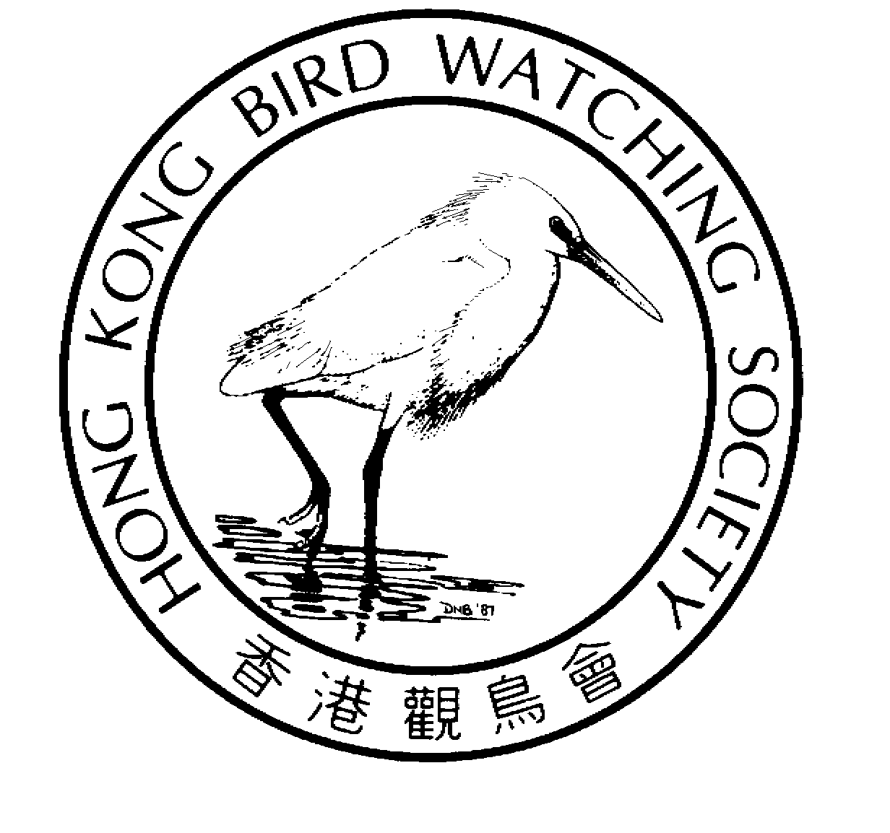 | Organized by  The Hong Kong Bird Watching Society  香港觀鳥會策劃
 | Sponsored by  Agriculture, Fisheries and Conservation Department  漁農自然護理署資助

Egretry Count

Training Workshop 2009
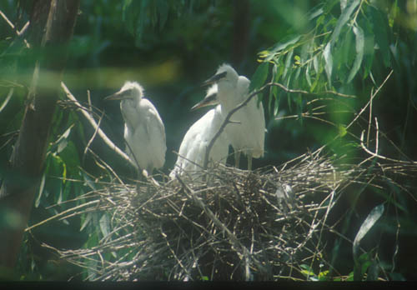
水鳥普查是香港觀鳥會策劃及執行的專業雀鳥普查計劃。項目於一九七九年展開，二千年起更獲漁農自然護理署資助進行。

是項全年性的普查由多位資深鳥友於工餘時間協助進行，收集各鳥種數量資料。普查項目包括(1)每月水鳥普查；(2)遷徙水鳥統計以及(3)鷺鳥林統計。這些數據正是監察濕地的變遷及其瀕危品種和數量的改變的重要基礎資料。同時亦成為管理及保育內后海灣國際重要濕地的重要部份。近年鷺鳥林普查顯示繁殖鷺鳥正在上升，不但顯示我們的保育工作取得一定成績，也表示我們的工作更任重道遠。

「鷺鳥林普查訓練工作坊」的舉辦是希望讓更多鳥友認識鷺鳥林及鷺鳥普查的技巧，並鼓勵及提升更多鳥友參與鷺鳥普查工作。更重要的是，讓大家直接參與和貢獻在國際重要濕地的保育和管理工作，從而獲取更大的滿足感。

歡迎會員參與「鷺鳥林普查訓練工作坊」！

The Waterbird Monitoring Programme is an integrated professional programme coordinated by The Hong Kong Bird Watching Society. The Waterbird counts began in 1979. Since 2000, this project has been funded by Agriculture, Fisheries and Conservation Department.
活動重點：
- 分享鷺鳥林及鷺鳥普查的歷史
- 介紹普查不同鷺鳥林的技巧
- 在二至三個鷺鳥林實習點算技巧

Programme highlights include:
- History of egretry count in Hong Kong;
- Techniques of counting nests in different types of nesting colonies and;
- Field trials at 2 to 3 colonies

Tips: Bring your telescope
貼士：請自備雙筒望遠鏡

This is one of the largest programme of the Society with a number of active volunteers contributing their time, carrying out bird survey throughout the year, to collect population data at species level. The programme consists of three parts (1) Monthly Waterbird Surveys; (2) Shorebird Surveys and (3) Egretry Counts. These data are essential for monitoring the value of wetlands, endangered species, population and environmental changes. It forms an important component of the conservation and management of the Mai Po Inner Deep Bay Ramsar Site. Recent egretry counts indicate that the nesting egrets exhibit an increasing trend. In other words, our work will become more important to the conservation of egrets in Hong Kong.

The “Egretry Count Training Workshop” is designed to allow more members to participate in egretry count. It is a good opportunity to learn the techniques required for egretry counting at the Mai Po Inner Deep Bay area and other area of Hong Kong, plus, the satisfaction of contributing to the conservation and management work of the Ramsar Site.
Language 語言: Cantonese 以廣東話為主
Egretry Count Training Workshop |  | 鷺鳥林普查訓練工作坊
19 Apr 2009 (Sunday) |  | 2009年4月19日(星期日)
Time: 8:30 am – 3:00 pm |  | 集合時間：早上8:30至下午3:00
Meeting Place: 1/F., Sheung Shui KCRC |  | 集合地點：上水火車站一樓售票大堂

Registration is free – but space is limited 費用全免，名額有限

REGISTRATION 登記表格

Please register to us by fax or e-mail 登記可以傳真或電郵方式 (Fax：2314 3687 E-mail: hkbws@hkbws.org.hk)

I wish to attend the Egretry Count Training Workshop on 19 April 2008
我想參加2009年4月19日 的 鷺鳥林普查訓練工作坊

Name 姓名:__________________________ Contact no聯絡電話.: _______________Member會員: □ Yes是 □ No否

E-mail電郵: _________________________________
14/F., Ruby Commercial Building, 480 Nathan Road, Yaumatei, Kowloon, Hong Kong
香港九龍油麻地彌敦道480號鴻寶商業大廈14樓
Tel 電話: 2377 4387 Fax.傳真: 2314 3687 E-mail電郵: hkbws@hkbws.org.hk
--------------------------------------------------------------------------------------------------------------------------------------------

