Hong Kong Bird Watching Society
 Hong Kong Bird Race 2011 
Fundraising Event

To: Members and Friends of HKBWS

Help us to Conserve the Birds of Hong Kong

With the support of members, companies and birders in the last Bird Race, the Society has taken one big step forward in bird conservation by hiring a full-time staff, Beetle Cheng, to follow-up all related issues. You may notice that we gradually posted our action and opinion on related issues in our discussion forum to alert members what is happening now in Hong Kong. However, your participation is still essential in pursuing our common goal – an environment that suitable for people and birds.

To ensure the continuance of our work, YOU are cordially invited to participate in the “Hong Kong Bird Race 2011” in the following ways:

(1) take part in the bird race with your family members and friends and raise fund through this race;
(2) make donation to the Society directly.

“Hong Kong Bird Race” is a bird watching competition among the racing teams. Participants are required to spot and identify bird species as many as possible within 24 hours within Hong Kong territory. The team who get the highest number of bird species will become the winner.

Apache Lau, Chairman


Details

- Date & Time: 9 to 10 April 2011 (1300 - 1300) (Total 24 hours)*
- Categories:
Open Team | Members , friends, general public are all welcome
Student Team | Students from primary or secondary schools  * Competition start from 0600 - 1300, 10 April 2011

- Number of Team members: 3 to 6 per team, members and non-members are both welcome
- Awards:
Top Donor (Team) | One
HK Bird Race President Cup | Each Group with a Champion
HK Bird Race Best Record | Each Group with a Best Record Award

- Registration Fee per team:
Open Team | HK$600
Student Team | HK$200

- Training: Three training outings are provided for participants, especially suitable for beginners.
- Transportation: Participants are required to arrange their own transportation during the racing day.
- Deadline of registration: 31 Mar 2011
- Insurance: Participants are recommended to obtain appropriate insurance.

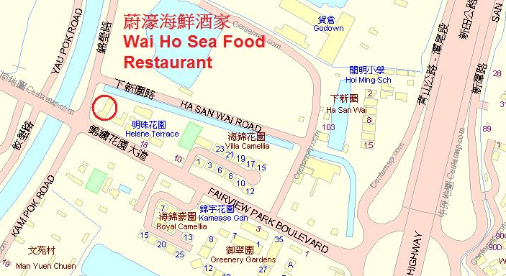
- Lunch & Prize Presentation:
Date: 2 pm, 10 April 2011
Venue: Wai Ho Sea Food Restaurant (Wai Ho Sea Food Restaurant B24A, Fairview Park Boulevard, Yuen Long. Website: www.waihoseafood.com)
Lunch fee: HK$100

- Inquiry: 2377 4387



Programme

Date & Time
- Open Team: 9 – 10 April 2011 (1300 – 1300) (Saturday – Sunday) (Total 24 hours)
- Student Team: 0600 to 1300, 10 April 2011 (Sunday) (Total 7 hours)

Rules of the Race
1) The Bird Race is a competition among different teams. Each team should comprise at least 3 and at most 6 participants. Both members and non-members are welcome.
2) Species will only be counted when at least three of the members agree the identification by observation or heard.
3) No transportation will be provided by the Society. Each team shall arrange its own transportation.
4) Each team may start the competition anywhere. Full team members should assemble at the Ending Checking Point (a) Mai Po Nature Reserve (the helicopter landing area beside the Mai Po car park); or (b) Wai Ho Sea Food Restaurant before 1300, 10 April 2011. Number of counts will be deducted by the number of minutes delayed in case of late arrival of any teams.
5) Please report the first day bird report to Mr. WY Lo (9457 3196) during 2100~2200 on 9/4/2011；
6) All teams are required to record the species in the Team Logbook provided by the Society. Team Captains should duly complete and submit the Team Logbook within 30 minutes after the competition, i.e. at 1330, to relevant person-in-charge.
7) All Team Logbooks will be examined by a group of adjudicators. They may, on their own judgment, ignore any unreasonable records.
8) Each team can elect one team member to be one of the adjudicators. Logbook of Student Teams will be examined by the representative of the Society.
9) Preliminary result of the competition will be announced during the lunch gathering. All teams should submit the formal records within two weeks, i.e. on or before 24 April 2011 to the Society for final verification.
10) Take a group photograph right after the race.

Bird Records
All species (Categories A to F of the “Avifauna of Hong Kong”) observed during the competition should be recorded and submitted to the Society. However, only species in Categories A to D will be considered, while those in Categories E and F will be excluded. (Please refer to the Team Logbook).

Restrictions
1) Attracting birds with audio recordings/facilities or baits are prohibited.
2) For the sake of safety and fairness, the following areas are strictly out of bounds to all teams:-
- All FCA including Lok Ma Chau, Sha Tau Kok & Lo Wu, except the board-walk
- No vehicles are permitted in the Mai Po Nature Reserve or on the restricted access road at Tai Po Kau Forestry Reserve and Deep Bay Road after the Tsimbeitsui Police Office, regardless of possession of valid permits.
3) No teams should approach known breeding sites. On no account should any birds be deliberately flushed.
HKBWS
 Hong Kong Bird Race 2011 
Pledge Form & Registration Form

To: HKBWS Office (Fax: 2314 3687 E-mail: hkbws@hkbws.org.hk Tel: 2377 4387)
(1) I/We are not able to participate in the Bird Race, but willing to donate: $1,000 $500 $200 $____________ to ____________________________ (Name of the team) OR  The Hong Kong Bird Watching Society Ltd
Name of Donor:______________________________________ Contact No.: __________________________________
Address of Donor: _________________________________________________________________________________
(2) We would like to register in the Bird Race (Please ✓)
Registration Fee per team:  Open Team—$600  Student Team—$200
Name of the Team: (Eng) |  | (Chi)
Name of Team Captain:1) |  | E-mail：
Mobile Phone No.: |  | E-mail：
Team Member: | 2) | 5)
Team Member: | 3) | 6)
Team Member: | 4)

(3) We shall have___________ team member(s) attending the Lunch gathering, totally cost $__________($100/per person)

(4) We would like to join the Bird Race Training
Training 1 | No. of Participants | Training 2 | No. of Participants | Training 3 | No. of Participants
Long Valley  2/4/2011 |  | Tai Po Kau  3/4/2011 |  | Mai Po  5/4/2011

------------------------------------------------------------------------------------------------------------------------------------------

 Pledge Form 
Name of Donor | Receipt  (✓) | Amount | Name of Donor | Receipt  (✓) | Amount | Name of Donor | Receipt  (✓) | Amount

*Donation of or above $100 is tax deductible (please put a ✓ in the box)
*This form could be duplicated if necessary.
*Donation could be paid at your convenience or within one week after the Race.
*Method of payment:
－Make cheque payable to “The Hong Kong Bird Watching Society Ltd” and send to our office;
－Direct credit to Bank of China (HK) Account Number: 012-878-1-076439-9, then return the receipt with this form to us;
－You can also visit our office directly.

*Office Address: 14/F., Ruby Commercial Building, 480 Nathan Road, Kowloon

