Magic Birding Circuit Ecuador
Trip Report
March 4 – 23, 2007

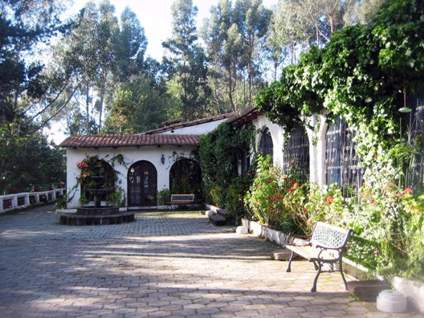
The Hosteria San Jorge was built as a traditional
18th Century Spanish Hosteria. It consists of 200
acres in the Pichincha Foothills. San Jorge is the
only reserve within minutes of the Capital of Quito
and it offers the incredible Magic Birding Circuit,
this consists of 5 nature and bird watching reserves
with the possibility of seeing over 800 species of
birds; it covers almost all of the altitudes in Ecuador
from the Paramo to the Sub tropical Rainforests.

March 4, 2007
Arrive Quito Airport, Dr. George Cruz waiting
for us with very warm and friendly greetings,
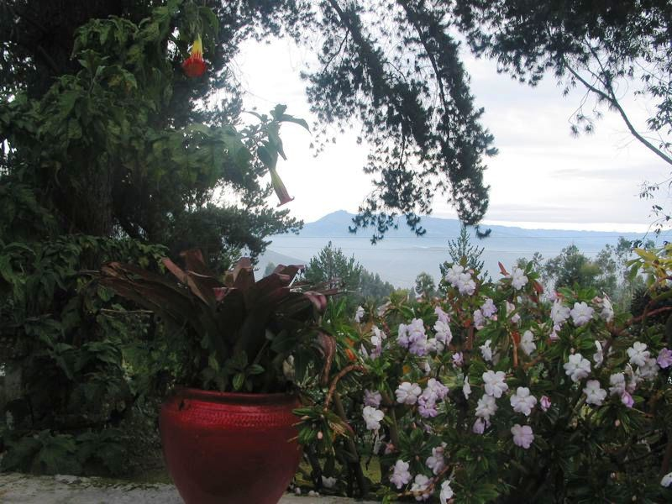
George is the owner of the San Jorge Magic Birding
Circuit, George transferred us to his Hosteria San
Jorge Botanical and Eco-Lodge. Friendly staff
and a big beautiful room with a cozy fireplace
awaited us. It was such a joy to stay here and be
so close to the city of Quito at the same time.

March 5, 2007
We had a day of rest to get acclimatized to the
high altitude.
After an excellent breakfast, which starts with
a fruit plate and then a main dish of your choice,
we then birded around the beautiful San Jorge
Hosteria and Botanical Reserve. We had a 4-course
lunch and dinner; all of the meals at both San Jorge
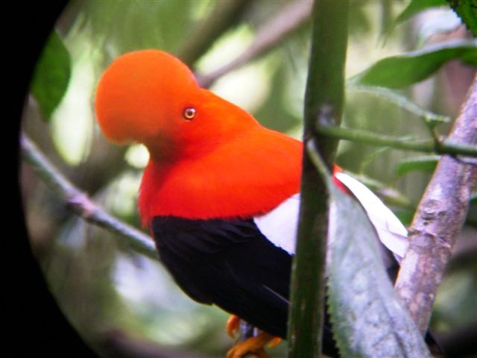
Quito and San Jorge de Milpe Eco-Lodges were
hand made varied and delicious. The grounds
surrounding the main Hosteria San Jorge Quito
are full of birds flitting around the tropical trees
in the many courtyards and gardens with wild
flowers that are very exotic, native and beautiful.
The High Barren Plains and Highland Rain Forest
surrounds the Hosteria and as you transverse and
go up in elevation it changes into Paramo, absolutely
breath taking.

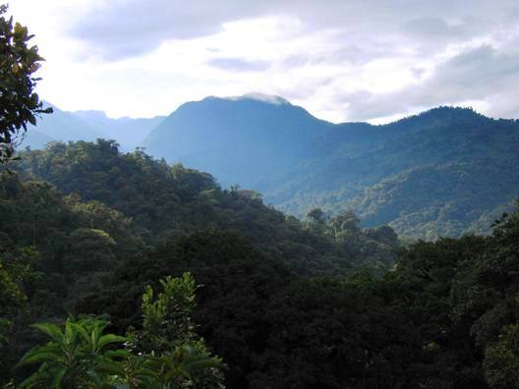
March 6, 2007
Today we hiked the High Barren Plains
and almost made it up to the Paramo
area of the Hosteria with George who
has a wealth of knowledge on the flora
and fauna of Ecuador, George also knows
a lot about the Ecuador and Inca history
and will recite some ancient lore at request,
we saw lots of birds as we hiked the beautiful
trails and there was even a waterfall.

March 7, 2007
Went to Yanacocha Hummingbird Reserve
which is in the Cloud Forest, 4 volunteer
Biologists who devote their time and experience
at all 5 of the San Jorge Eco-Lodges and
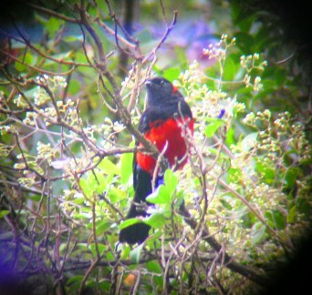
Reserves were our guides today, they were
very informative and identified a lot of the
birds we saw. Very beautiful scenery,
easy walking on the road and a gallery of
hummingbird feeders as a reward at the end
of the walk.

March 8, 2007
George and his wife Irina took us to the famous
Nono-Mindo Road in the Tandayapa Valley,
this Cloud Forest is part of the Choco Endemic
Bird Area of Northwest Ecuador, between
dmiring the panoramic views we did see lots
of birds, including the infamous Andean Cock
f the Rock.

March 9, 2007
Irina drove us back to the Nono-Mindo Road
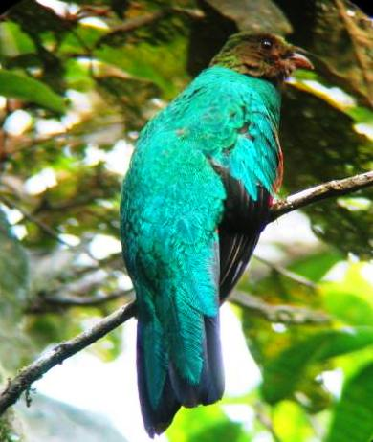
where we did more bird watching and sight seeing.

March 10, 2007
We went to San Jorge de Tandayapa today;
this Reserve is located in the Cloud Forest of
the Tandayapa Valley, we bird watched along
the main road and up to the Hummingbird Reserve,
we saw among other birds a total of 19 species
f hummingbirds. What a beautiful Reserve, the views
are magnificent from the bungalow deck, sitting there
I felt like we were in a beehive with all of the
ummers buzzing around us for hours and cooperating
hen we took their pictures. We had a lovely picnic lunch
nd relaxed while admiring all the exotic plants and birds
in this gorgeous area.
Transferred to the San Jorge de Milpe Reserve in the late afternoon.

March 11, 2007
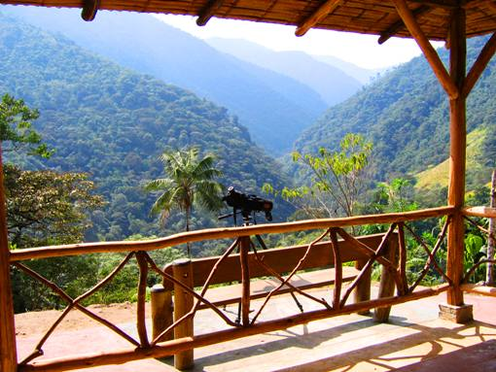
San Jorge de Milpe Reserve has a spectacular hand
made wooden 2-story Eco-Lodge with a huge
observation deck on both levels, offering us a view
of the river gorge and surrounding Sub-Tropical
Rainforest. We saw a lot of mixed flocks just
from this deck. The trails are extensive and well
groomed; the rainforest is full of birds, orchids and
bromeliads hanging from the moss-covered trees.
There are hummingbird feeders all around the open-air
dining room so you can enjoy your meal and watch the
hummers at the same time. An absolutely gorgeous
Eco-Lodge. A must for your itinerary to stay here
or at least 4-6 days, a bird watchers paradise for sure.

March 12, 2007
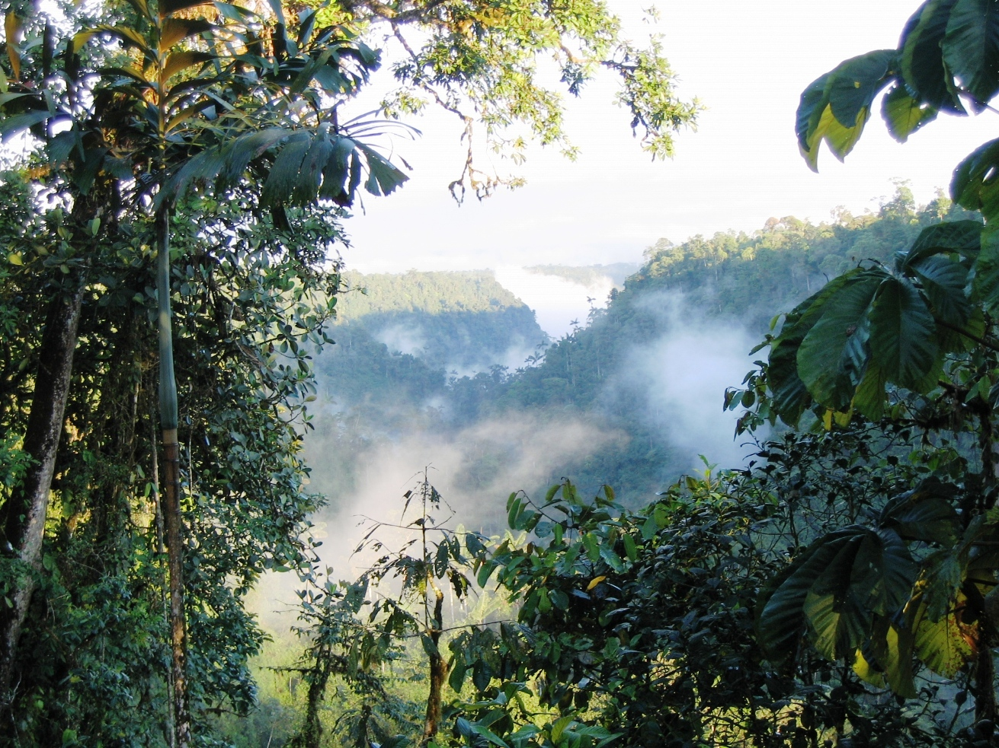
Bird watching on the many trails of San Jorge de Milpe
is absolutely fantastic, we even indulged in swimming
at 4 out of 5 spectacular cascading waterfalls San Jorge de
Milpe offers. Very soothing, refreshing and lots of fun.

March 13, 2007
First thing this morning we went to the Observation site,
from here you have a panoramic view for miles, this
was a great spot to start every morning, parrots, toucans,
swallows and tanagers abound. We then bird watched
along some trails at San Jorge de Milpe and along the
main road in from the high way, there was a lot of
mixed flocks all around the fields. In the evenings moths
are very numerous around any lights left on for the purpose
of seeing these incredible creatures, some the size of
my hand and some small and extremely colourful.

March 14, 2007
Went into the town of Mindo today, bird watched while
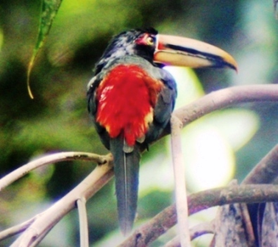
driving along and at Nambillo Waterfalls, the highlight
of the day was the Swallow-tailed nightjar at some cliffs
on the way back to San Jorge de Milpe.

March 15, 2007
George and Irina drove us to Pedro Vicente Maldonado,
which is a Sub-Tropical area; this lower altitude is very
warm and humid. We bird watch walking along the road.
We saw a lot of different species of birds here.

March 16, 2007
Transferred back to San Jorge Hosteria Botanical Eco-Lodge.

March 17, 2007
Day of well deserved rest and enjoying the hospitality.

March 18, 2007
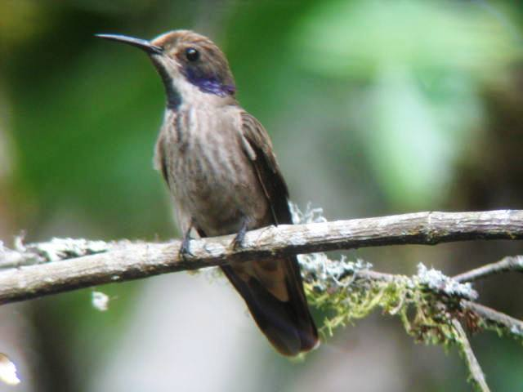
George and his family drove us to the famous Otavalo Market
and surrounding shops. We had to make some big decisions
when choosing some souvenirs for our friends and family,
the variety of lovely handmade crafts, wall hangings
and silver is quite extensive, with a lot of translation and
help from Irina and Gabriella we had a lot of fun making our
purchases.

March 19, 2007
George took us up to the Eastern Slope of the Andes into
the High Barren Plains of the Papallacta Pass; this area
is famous for their Volcanic Thermal Hot Springs. Very
unique scenery in the Paramo, bird watched here for the
morning then we went for a few hours at Cuyuja Gardens,
there were lots of hummingbird feeders at the gardens and
a Crested Quetzal watching over us, we then drove off to
Baeza where we spent the next couple nights.
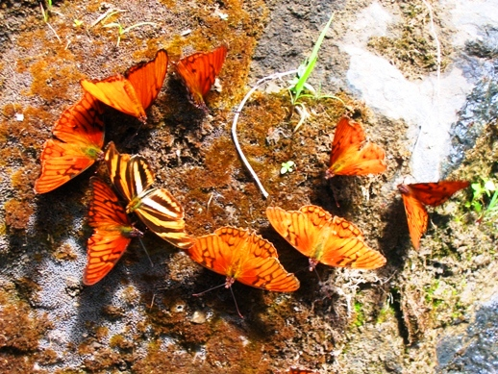

March 20, 2007
George drove us today to the Andes Cloud Forest of
San Jorge de Cosanga /Yanayacu Bird & Wildlife Reserve,
these 2 Reserves are beside the San Isidro Valley and
is surrounded by 120,000 hectares of the Antizana National
Park Reserve. This area is so untouched and exquisite I
expected to see a spectacled bear at any time. There were
so many birds on the trail up to San Jorge Cosanga that we
went up and down the trail twice.
There was one tree that had an amazing number of 10
Crested Quetzals, both males and females. One highlight
of the day was on the way home we stopped at a cliff and
saw the Lyre-tailed Nightjar. Definitely well worth your
while to spend at least 2 to 3 days here bird watching.

March 21, 2007
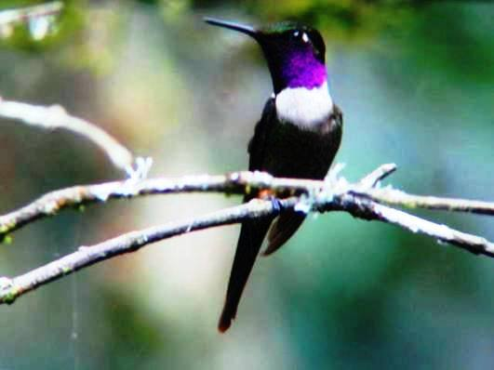
An excursion not planned on our itinerary but it goes to
show you just what a special person George is, we spent
the day bird watching the road to Coca in the Sub-Tropical
Rainforest of the Amazon Basin, we saw an unbelievable
amount of birds, particularly the paradise tanagers.
Orchids and other flowers were growing everywhere along the road.

March 22, 2007
Another well deserved day of rest and pampering at San Jorge
Hosteria.

March 23, 2007
A morning of sad departure.
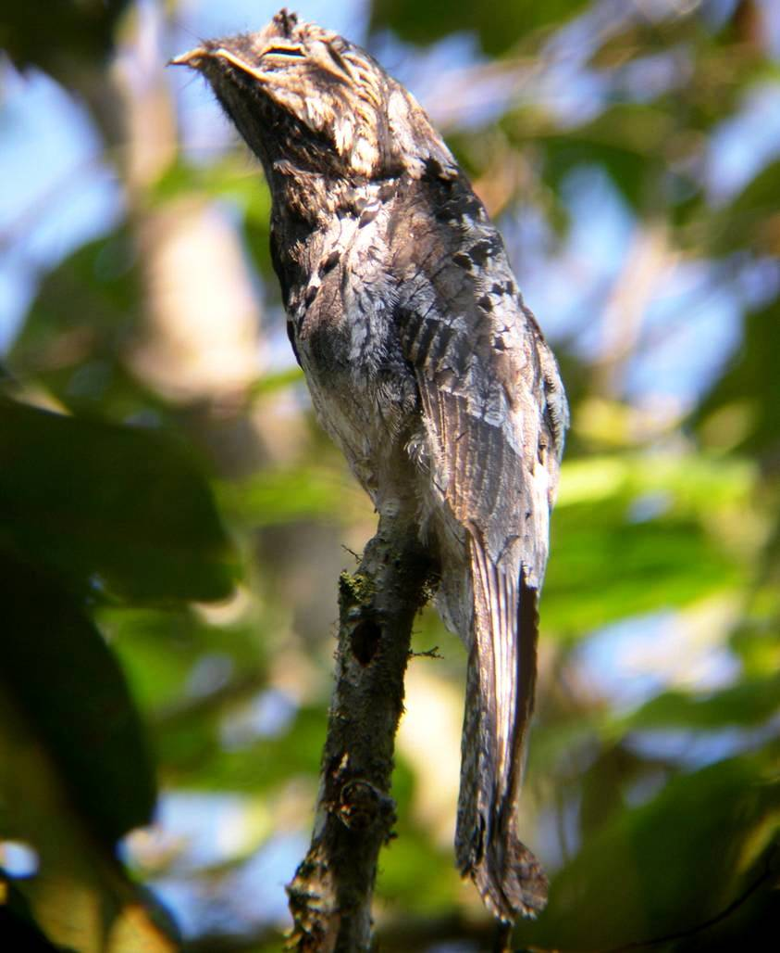
Special thanks to George and Irina Cruz who made
this for us the best bird watching trip we have ever taken,
their undivided attention to us, their desire to grant all of
our wishes and needs was incredible.
Through their guidance and expertise we saw a total of
405 different species of birds. I would highly recommend
Hosteria San Jorge Botanical Eco-Lodge Quito,
San Jorge de Milpe Eco-Lodge, San Jorge de Tandayapa
Hummingbird Reserve, San Jorge de Yanayacu Reserve and
San Jorge de Cosanga Bird and Wildlife Reserve to everyone
who wants to experience the incredible beautiful Country of
mainland Ecuador and all of its exquisite birds along a
Very Magic Birding Circuit.

For more information on The Magic Birding Circuit and birding lists, visit:
www.hostsanjorge.com.ec http://www.hostsanjorge.com.ec/
www.eco-lodgesanjorge.com http://www.eco-lodgesanjorge.com/

Trip list of birds and photos of Ecuador on the next few pages.

Gerry and denise Doekes
P.O. Box 226
Norval, ON, Canada
L0P 1K0

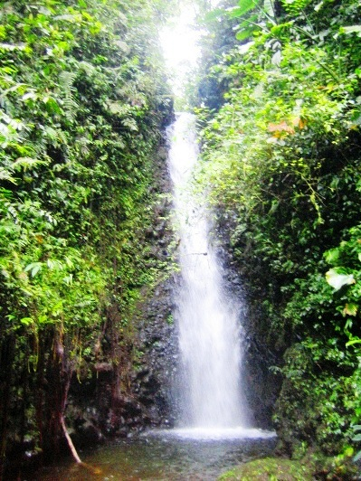
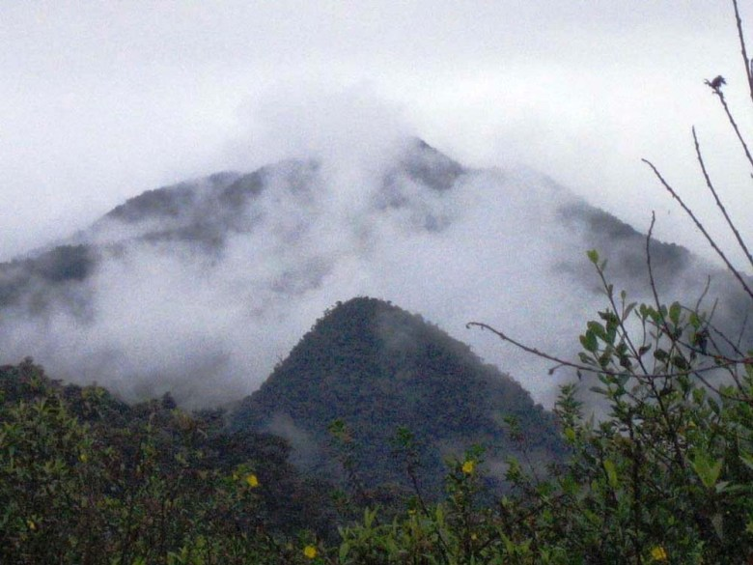

List of Birds

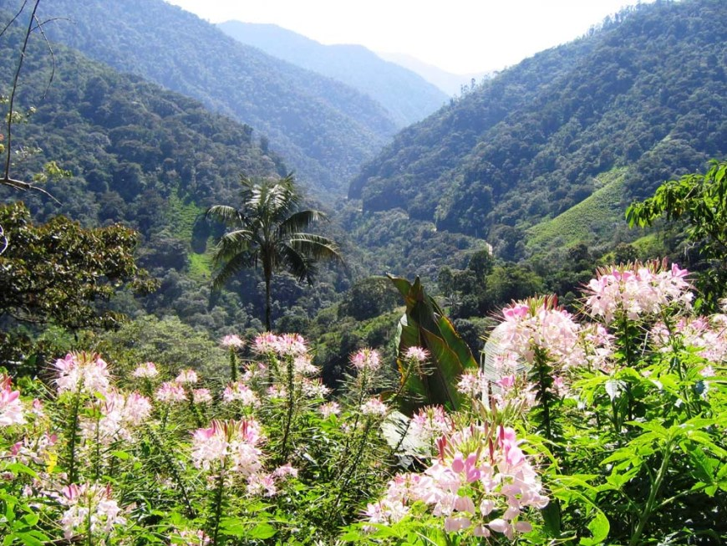
I have listed only the new birds we saw
during our Magic Birding Circuit. George
Cruz (owner and our guide) saw a lot more
birds than we did; I did not list those birds.

Hosteria San Jorge Quito-

Highland Barren Plains, Highland

Rainforest & Paramo

Tawny Antpitta, Cinereous Conebill, Red
Crested Cotinga, Eared Dove, White-tipped Dove,
White Crested Elaenia, Rufous-naped Brush-Finch,
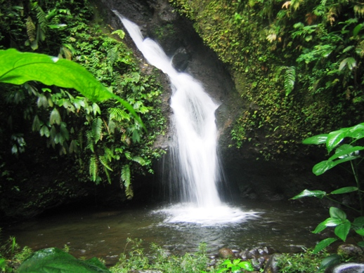
Black Flower-piercer, Masked Flower-piercer,
Southern-Yellow Grosbeak, Variable Hawk,
Tyrian Metaltail, Band-tailed Nightjar, Band-winged
Nightjar, Barred Parakeet, Band-tailed Pigeon,
Rock Dove, Sapphire-vented Puffleg, Great
Sapphirewing, Paramo Seedeater, Plain-coloured
Seedeater, Hooded Siskin, Rufous-collared
Sparrow, Azara’s Spinetail, Shining Sunbeam,
Brown-bellied Swallow, White-collared Swift,
Blue and Yellow Tanager, (H) Buff-breasted
Mountain Tanager, Scarlet-bellied Mountain
Tanager, (H) Ash-coloured Tapaculo,
H) Unicoloured Tapaculo, Purple-backed Thornbill,
Great Thrush, Curve-billed Tinamou, Black-tailed
Trainbearer, Green-tailed Trainbearer, Pearled
Tyrannulet, Smoky Bush-Tyrant, Tufted Tit-Tyrant,
Mountain Velvetbreast, Green Violet-ear, Sparkling
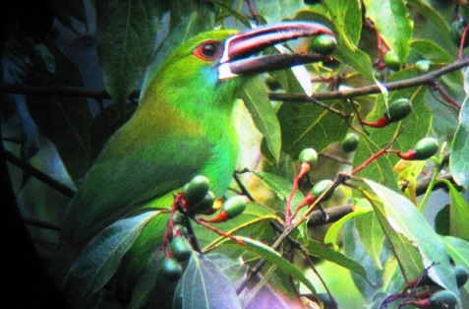
Violet-ear, Black-crested warbler, Slate-throated
Whitestart, Spectacled Whitestart, White-bellied Woodstar.

San Jorge de Milpe- Subtropical Rainforest

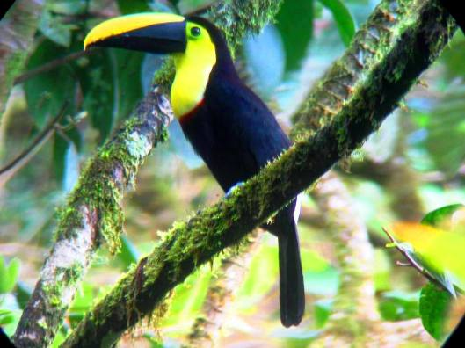
Smooth-billed Ani, Bicoloured Antbird, Esmeraldas
Antbird, Immaculate Antbird, Long-tailed Antbird,
(H) Ochre-breasted Antpitta, (H) Scaled Antpitta,
Russet Antshrike, Pale-mandible Aracari, Bananaquit,
Toucan Barbet, Cinnamon Becard, Yellow-collared
Chlorophonia, Velvet-purple Coronet, Shiny Cowbird,
Cattle Egret, Greenish Elaenia, Grey Elaenia, Lesser
Elaenia, Bat Falcon, Chestnut-capped Brush-Finch,
Tricoloured Brush-Finch, Black-headed Tody-Flycatcher,
Boat-billed Flycatcher, Golden-crowned Flycatcher,
Ornate Flycatcher, Rusty-margined Flycatcher, Slaty-capped
Flycatcher, Social Flycatcher, Sulphur-rumped Flycatcher,
White-ringed Flycatcher, Buff-fronted Foliage-gleaner,
Buff-throated Foliage-gleaner, Scaly-throated Foliage-gleaner,
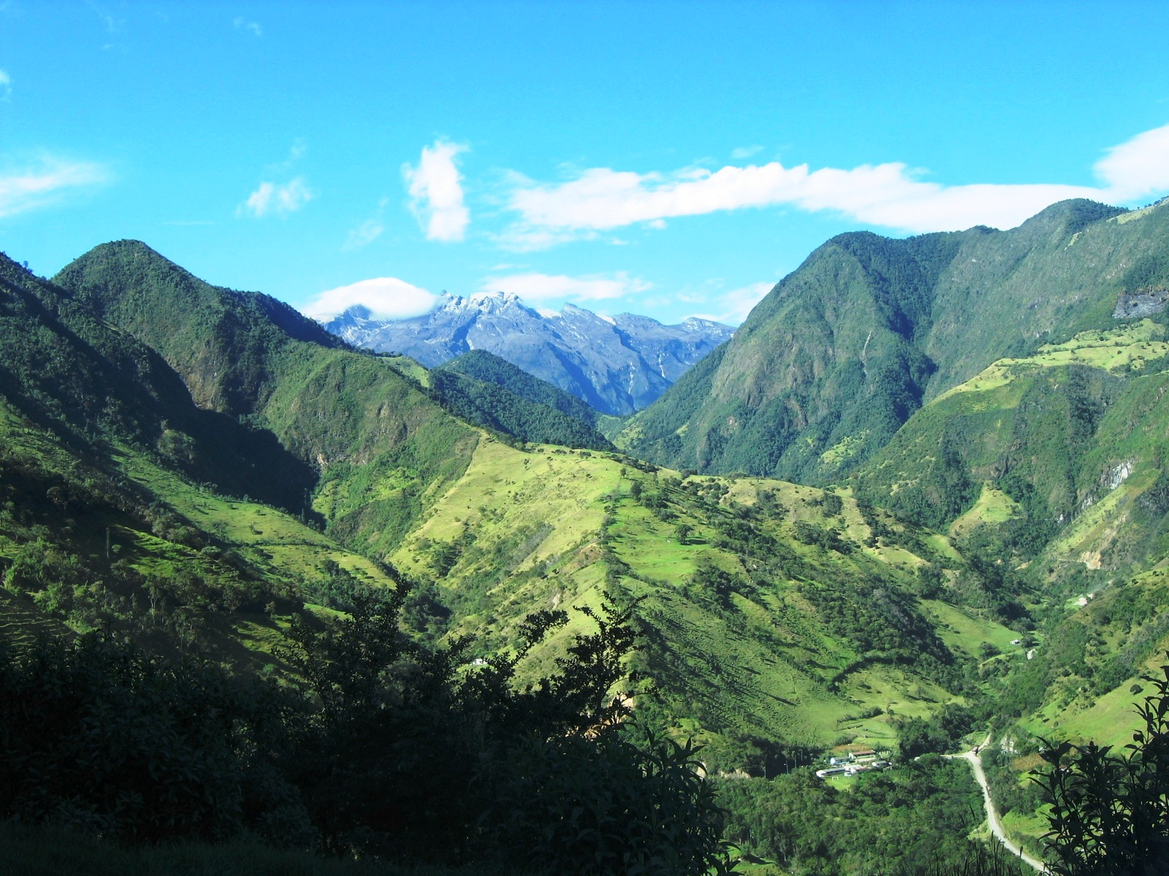
Scaled Fruiteater, Tawny-faced Gnatwren, (H) Wattled
Guan, Fasciated Tiger-Heron, Pacific Hornero, Green
Honeycreeper, Brown Inca, Golden-winged Manakin,
White-bearded Manakin, Lanceolated Monklet,
(H) Cloud-forest Pygmy-Owl, Maroon-tailed
Parakeet, Red-masked Parakeet, Bronze-winged Parrot,
Tropical Parula, Ruddy Pigeon, Common Potoo,
Dark-backed Wood-Quail, (H) Brown-billed Scythebill,
Western Sirystes, (H) Andean Solitaire, White-throated
Spadebill, Orange-billed Sparrow, Blue and White Swallow,
White-thighed Swallow, Grey-rumped Swift, Orange-bellied
Euphonia, Bay-headed Tanager, Blue-grey Tanager,
Blue-necked Tanager, Dusky Bush-Tanager, Emerald Tanager,
Glistening-green Tanager, Grey and Gold Tanager, Guira Tanager,
Ochre-breasted Tanager, Palm Tanager, Rufous-throated Tanager,
Silver-throated Tanager, Swallow Tanager, White-lined Tanager,
White-winged Tanager, Yellow-throated Bush-Tanager, Green
Thorntail, Orange-bellied Euphonia, Swainson’s Thrush,
Black-crowned Tityra, Masked Tityra, Choco Toucan,
Chestnut-Mandibled Toucan, Streak-capped Treehunter,
Collared Trogon, Choco Trogon, Yellow Tyrannulet,
Masked Water-Tyrant, Scale-crested Pygmy-Tyrant,
Black Vulture, Buff-rumped Warbler, Choco Warbler,
Montane Woodcreeper, Plain-brown Woodcreeper,
Strong-billed Woodcreeper, Wedge-billed Woodcreeper,
(H) Crimson-bellied Woodpecker, Guayaquil Woodpecker,
Lineated Woodpecker, Grey-breasted Wood-Wren,
House Wren, Sepia-brown Wren.

Tandayapa & Nono-Mindo Road-

Highland Rainforest

Chestnut-crowned Antpitta, (H) Giant Antpitta,
(H) Rufous-breasted Antthrush, Red-headed
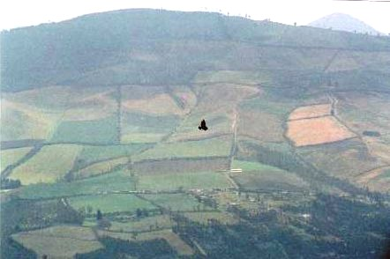
Barbet, Barred Becard, Scrub Blackbird, Empress
Brilliant, Green-crowned Brilliant,
Andean Cock-of-the-Rock, Buff-tailed Coronet,
Squirrel Cuckoo, White-capped Dipper,
White-tipped Dove, Sierran Elaenia, Andean Emerald,
Western Emerald, Golden-rumped Euphonia, Orange-bellied
Euphonia, Thick-billed Euphonia, Slaty Finch,
White-sided Flower-piercer, Bran-coloured Flycatcher,
Cinnamon Flycatcher, Flavescent Flycatcher,
Golden-crowned Flycatcher, Streak-necked Flycatcher,
Blue-black Grassquit, Dull-coloured Grassquit,
Sickle-winged Guan, Broad-winged Hawk, Roadside
Hawk, Tawny-bellied Hermit, Rufous-tailed Hummingbird,
Speckled Hummingbird, Collard Inca, White-necked Jacobin,
Beautiful Jay, Turquoise Jay, Snowy-throated Kingbird,
Tropical Kingbird, Ringed Kingfisher, Hook-billed Kite,
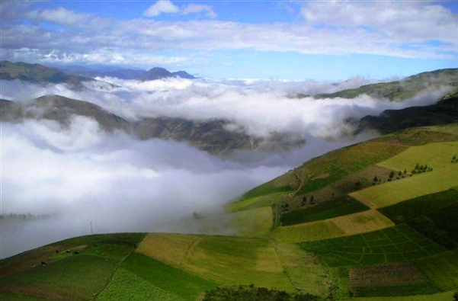
Swallow-tailed Kite, Red-billed Parrot, Smoke-coloured
Pewee, Black Phoebe, Plumbeous Pigeon, Golden-headed
Quetzal, Booted Racket-tail, Black-winged Salatator,
Variable Seedeater, Yellow-bellied Seedeater,
Azara’s Spinetail, (H) Slaty Spinetail, Gorgeted Sunangel,
Barn Swallow, Southern Rough-winged Swallow,
Violet-tailed Sylph, Beryl-spangled Tanager, Black-capped
Tanager, Blue-capped Tanager, Blue-grey Tanager,
Blue-winged Mountain Tanager, Flame-faced Tanager,
Golden Tanager, Golden-naped Tanager, Grass-green
Tanager, Lemon-rumped Tanager, Metallic-green Tanager,
Rufous-chested Tanager, (H) Narino Tapaculo, Ecuadorian
Thrush, Glossy-back Thrush, Plate-billed Mountain Toucan,
Crimson-rumped Toucanet, Masked Trogon, Southern-beardless
Tyrannulet, White-tailed Tyrannulet, Rufous-breasted Chat-Tyrant,
Slaty-backed Chat-Tyrant, Smoky Bush-Tyrant, Streak-throated
Bush-Tyrant, Brown Violet-ear, Green Violet-ear, Sparkling
Violet-ear, Brown-capped Vireo, Red-eyed Vireo, Turkey Vulture,
Blackburnian Warbler, Cerulean Warbler, Russet-crowned Warbler,
Tennessee Warbler, Three-striped Warbler, Purple-bibbed Whitetip,
Montane Woodcreeper, Green-crowned Woodnymph, Bar-bellied
Woodpecker, Crimson-mantled Woodpecker, Powerful Woodpecker,
Purple-throated Woodstar, White-bellied Woodstar,
(H) Plain-tailed Wren.

San Jorge de Cosanga- Cloud Forest

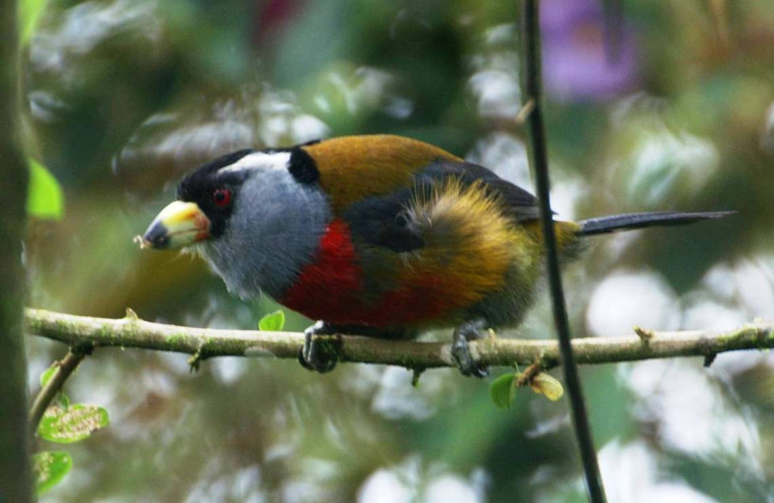
(H) White-throated Quail Dove, Bluish
Flower-piercer, Rufous-breasted Flycatcher,
Sickle-winged Guan, Black-eared
Hemispingus, Bronzy Inca, Lyre-tailed Nightjar,
Russett-backed Oropendola, Foothill-Screech
Owl, Eastern Wood Pewee, (H) Andean Potoo,
Rufous-breasted Wood-Quail, Olivaceous Siskin,
Common Bush-Tanager, Flame-faced Tanager,
Saffron-crowned Tanager, Yellow-whiskered Bush-
Tanager, (H) Cusquea Tapaculo, (H) Equatorial
Rufous-vented Tapaculo, Flammulated Treehunter,
Streaked Tuftedcheek, Canada Warbler, Russet-crowned
Warbler, Ocellated Woodcreeper, Olive-backed
Woodcreeper, Tyrannine Woodcreeper.

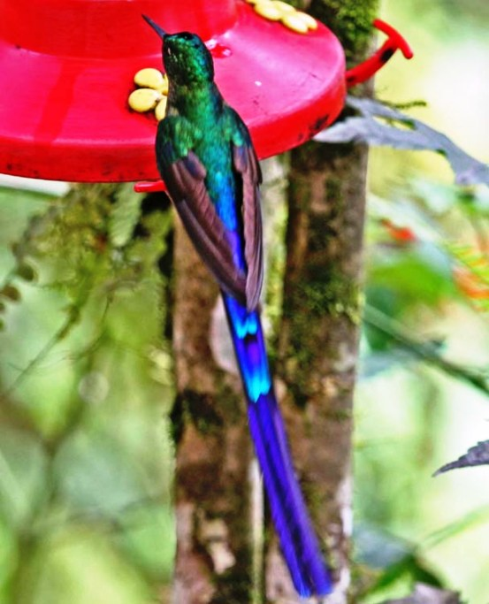

Mindo / Nambillo Falls- Cloud Forest

Dot-winged Antwren, Broad-billed Motmot, Rufous
Motmot, Club-wing Manikin (H), Swallow-tailed Nightjar,
Black-and-white Owl, Torrent Tyrannulet, Bay Wren,
Whiskered Wren.

Yanacocha- Cloud Forest &

Highland Rainforest

(H) Undulated Antpitta, Blue-backed Conebill,
Black-chested Buzzard-Eagle, Glossy Flower-piercer,
Barred Fruiteater, Andean Guan, Superciliaried Hemispingus,
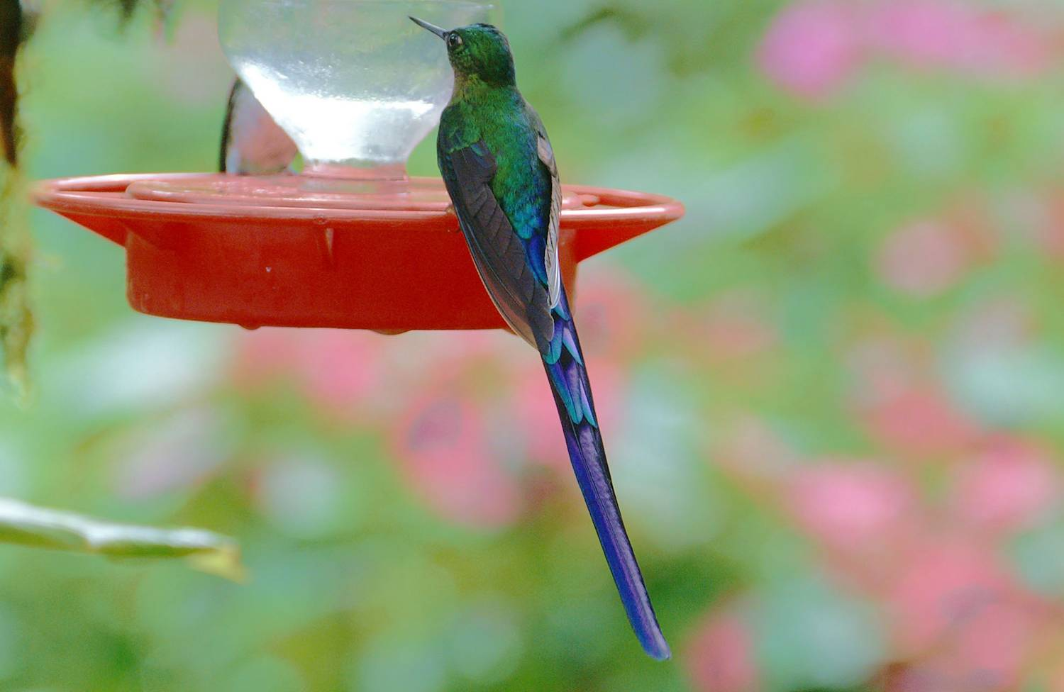
Sword-billed Hummingbird, American Kestrel,
Golden-breasted Puffleg, Buff-winged Starfrontlet,
Black-chested Mountain-Tanager, Blue and Black
Tanager, Hooded Mountain-Tanager, Rainbow-bearded
Thornbill, Pearled Treerunner, Brown-backed Chat Tyrant,
Crowned Chat-Tyrant.

Pedro Vicente Maldonado-

Subtropical Forest
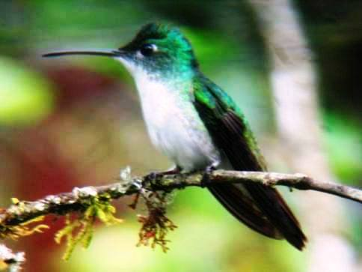
Slaty Becard, Red-rumped Cacique, White-throated
Crake, Little Cuckoo, Striped Cuckoo, Yellow-tufted
Dacnis, Lesser Seed-Finch, Common Tody-Flycatcher,
Dusky-capped Flycatcher, Ochre-bellied Flycatcher,
Olive-striped Flycatcher, Sooty-crowned Flycatcher,
Tawny-breasted Flycatcher, Northern Tufted Flycatcher,
Tropical Gnatcatcher, Double-banded Greytail, Purple
Honeycreeper, Blue-chested Hummingbird,
Purple-chested Hummingbird, Violet-bellied Hummingbird,
Plumbeous Kite, Pacific Parrotlet, Western Wood-Pewee,
Olivaceous Piculet, Dusky Pigeon, Black-winged Saltator,
Buff-throated Saltator, Yellow-bellied Siskin, House
Sparrow, Band-rumped Swift, Lesser Swallow-tailed
Swift, Dusky-faced Tanager, Golden-hooded Tanager,
Pale-vented Thrush, Golden-faced Tyrannulet,
Tawny-crowned Pygmy-Tyrant, Cinnamon Woodpecker,
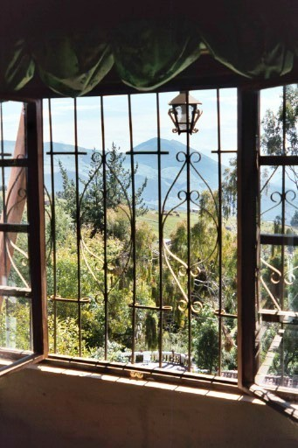
Red-rumped Woodpecker, Black-chinned Woodpecker,
Plain Xenops, Streaked Xenops.

Papallacta Pass & Cayuga Gardens-

Cloud Forest & Paramo

Fawn-breasted Brilliant, Northern Mountain
Cacique, Many-striped Canastero, Bar-winged
Cinclodes, Stout-billed Cinclodes, Chestnut-breasted
Chlorophonia, Giant Conebill, Chestnut-breasted Coronet,
Torrent Duck, Pale-naped Brush Finch, Plumbeous
Sierra-Finch, Ecuadorian Hillstar, Speckled Hummingbird,
Inca Jay, White-capped Parrot, Dusky Piha, Yellow-billed
Pintail, Crested Quetzal, Spotted Sandpiper, Rufous-bellied
Seedsnipe, Andean Tit-Spinetail, Tourmaline Sunangel,
Long-tailed Sylph, Blue-mantled Thornbill, Emerald
Toucanet, Black-capped Tyrannulet, Sulphur-bellied
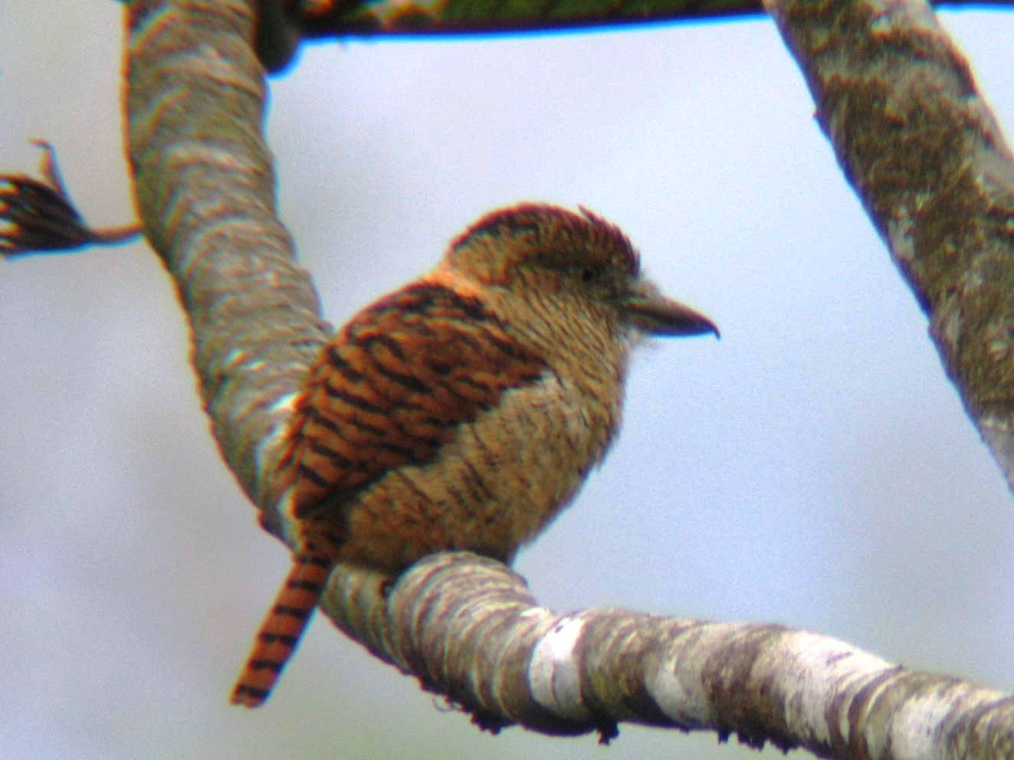
Tyrannulet, White-banded Tyrannulet, White-throated
Tyrannulet, Paramo Ground-Tyrant, Red-rumped
Bush-Tyrant, Amethyst Woodstar, White-bellied
Woodstar, Mountain Wren, Rufous Wren, Sedge Wren,
Greater Yellowlegs.

Road to Coca-

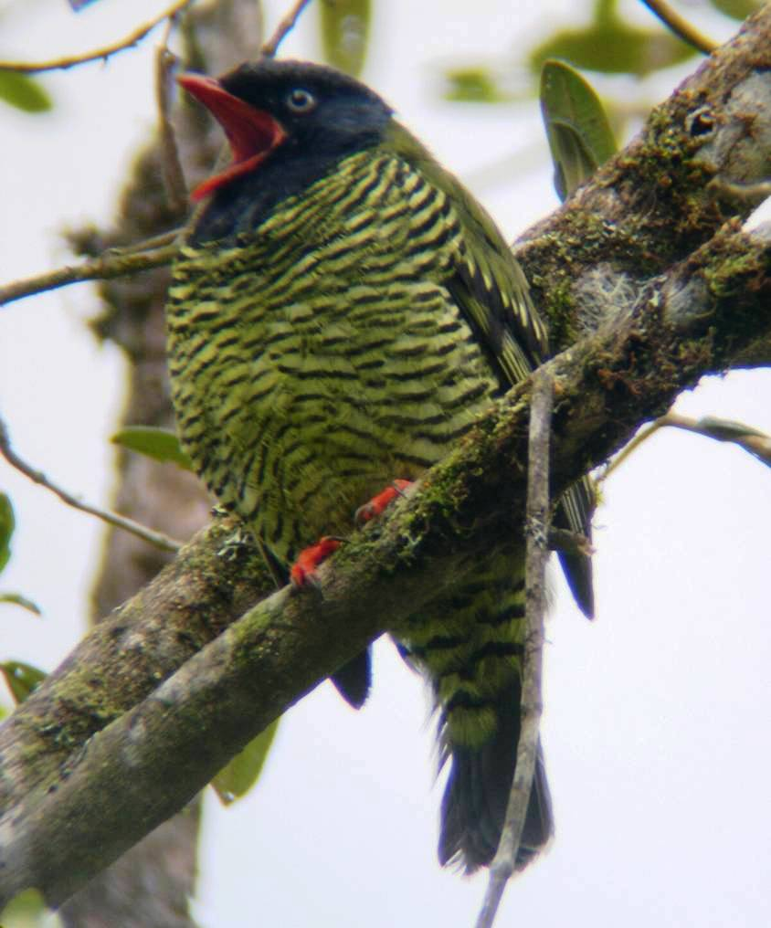
Amazon Basin Tropical Rainforest

Lettered Aracari, Many-banded Aracari,
Black-faced Dacnis, Blue Dacnis, White-bellied
Dacnis, Glittering-throated Emerald, Olive Finch,
Crowned Slaty-Flycatcher, Piratic Flycatcher,
Willow Flycatcher, Bare-necked Fruitcrow,
Fiery-throated Fruiteater, Great-tailed Grackle, Equatorial
Greytail, Rufescent Tiger-Heron, White-throated Kingbird,
Mealy Parrot, Lafresnaye’s Piculet, Greyish Saltator,
Streaked Saltator, Black and White Seedeater, Rufous-bellied
Seedsnipe, Ash-browed Spinetail, White-banded Swallow,
White-winged Swallow, Short-tailed Swift, Magpie
Tanager, Masked Crimson Tanager, Orange-eared Tanager,
Paradise Tanager, Scarlet Tanager, Silver-beaked Tanager,
Spotted Tanager, Summer Tanager, Turquoise Tanager,
Yellow-bellied Tanager, Black-billed Thrush, Long-tailed
Tyrant, Blackpoll warbler, Crimson-crested Woodpecker,

