ANNEXES – Photos for TP326/TPT60

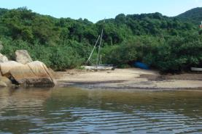
Landscape value and Visual Impact – note that not a single house is in sight from the Marine Park. The site application is in the field behind and diagonally to the left of the boat, just 30 metres from this Marine Park beach.

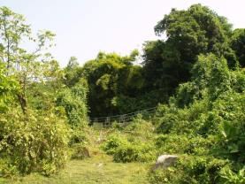

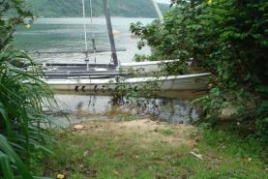
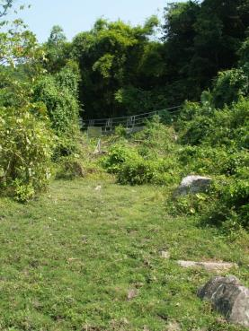
Geotechnical Impact - note the site which is at the top of the field near the railings is on a slope, with a seasonally-wet grassland before it which drains into the Marine Park waters

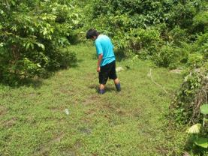
Environmental Impact and Sewerage Impact Assessment - Note the close proximity of the site to the Marine Park, a Site of Special Scientific Interest (SSSI). The proposed septic tank will be a mere 30 metres away from the SSSI. It is unlawful to have septic tank effluent within 100 metres of an SSSI.

There are 2 streams in the application site field, both of which exit into the Marine Park.
One is a permanent stream; the other is a seasonal stream.
This first photo is of the permanent stream:
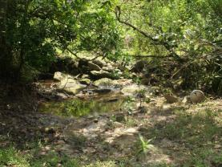

The other 3 photos are of the seasonal stream which is less than 15 metres from the application site:
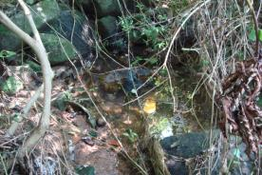
Environmental Impacts and Sewerage Impact
(a) note that it is unlawful to have septic tank effluent within 15 metres of a stream. This stream is less than 15 metres from the site.
(b) The seasonal stream photos were taken on Sunday 8 September 2013, when freshwater shrimps were observed in the seasonal stream.

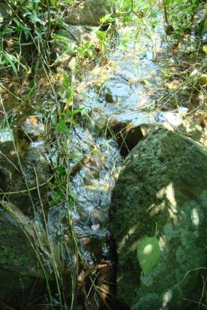
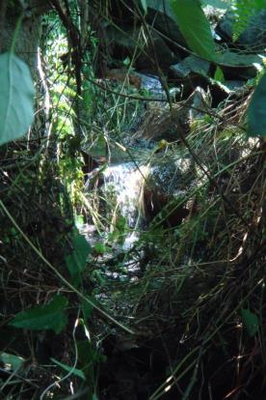

Criminal Acts

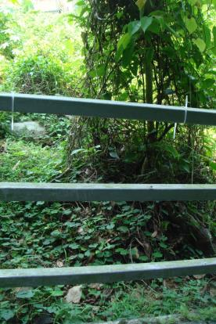
Note the plastic tags on the footpath railings adjacent to the site. There was supposed to be a Notice attached here drawing the public’s attention to the housing application and inviting objections. The Notice was removed during the objection period, which fact was brought to the attention of TPB and the LDO on Friday 6 September.
This photo was taken on Sunday 8 September. Note that the notice has not been replaced. The deadline for objections is Tuesday 10 September.

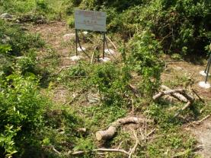
The application site was unlawfully cleared of trees and shrubs on 9 July 2012. This environmental vandalism impacts upon a Tree Survey.
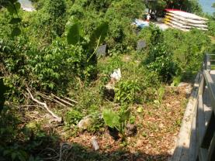
Landscape and Visual Impacts
Note that the Marine Park view from the public footpath will be blocked by a house on this site.
Note that the view will be blocked of not one but of 2 Marine Park beaches from the public footpath. The proposed house will be equidistant between the 2 beaches.
There is only one footpath to the bathing beach, the historic Lime Kilns, and the WWF Marine Life Centre – the majority of visitors to Hoi Ha Marine Park walk along this footpath. The natural landscape views from the footpath should be protected.

Environmental and Sewerage Impact Assessment
The application site is within 30 metres of this bathing beach. It is unlawful to have septic tank effluent within 100 metres of an SSSI and within 100 metres of a bathing beach.

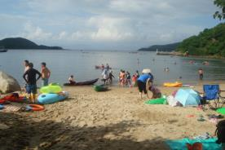
Landscape and Visual Impact of the site
This is a popular bathing beach. People come to enjoy the scenery which is an area of outstanding natural beauty, not to walk through a beach-front housing estate. Currently, looking from this beach towards the village footpath, there is not a house in sight. The housing application is for a site right in the very middle of this photograph.
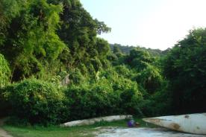

Traffic (pedestrian) Impact and Risk Assessment
The footpath which leads to the application site is already gridlocked at peak times. A housing development to the left of the railings will exacerbate the problem and make pedestrian traffic jams even more hazardous.
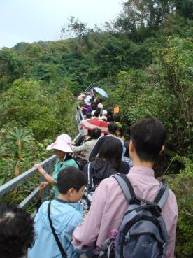
The access to the site is steep and hazardous – there are already accidents at the point of access:
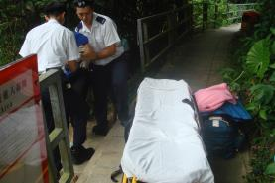

Traffic (vehicular) Impact
There is no road to the application site, only a public footpath. Friends of Hoi Ha and the residents of Hoi Ha have been excluded from the talks between HAD and the Indigenous Village Representative and the Resident Village Representative on the Representatives’ request for development/improvements of this footpath. It should not be widened into an access road – this is a public footpath to a Marine Park, the WWF Centre, and the Wan Tsai Extension Camp site in Sai Kung Country Park.
Where would a prospective owner of this house park his car? There is no public transport from Hoi Ha before 8.30 am, and no public transport to Hoi Ha after 6 pm. Hoi Ha is at a remote location, it is 16 km away from the nearest shops. Residents need private vehicles in order to live at Hoi Ha. If this house is built as 3 apartments, that will mean a minimum of 3 more cars. The village car park is full – there is no room for any more vehicles. Visitors to Hoi Ha are already having to park their vehicles illegally around the roundabout and illegally on the pavements along the Hoi Ha Road.
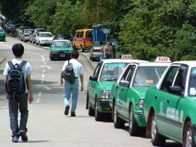

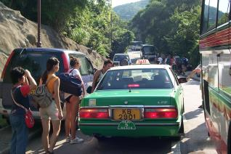

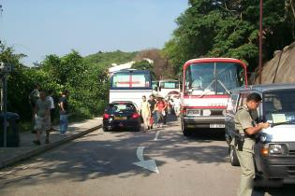
This illegal parking of vehicles is dangerous. It blocks the road and blocks the public footpath, forcing pedestrians onto the road. A child has already had his foot run over by a taxi, and a visitor on a WWF educational tour has been hit by a car.

